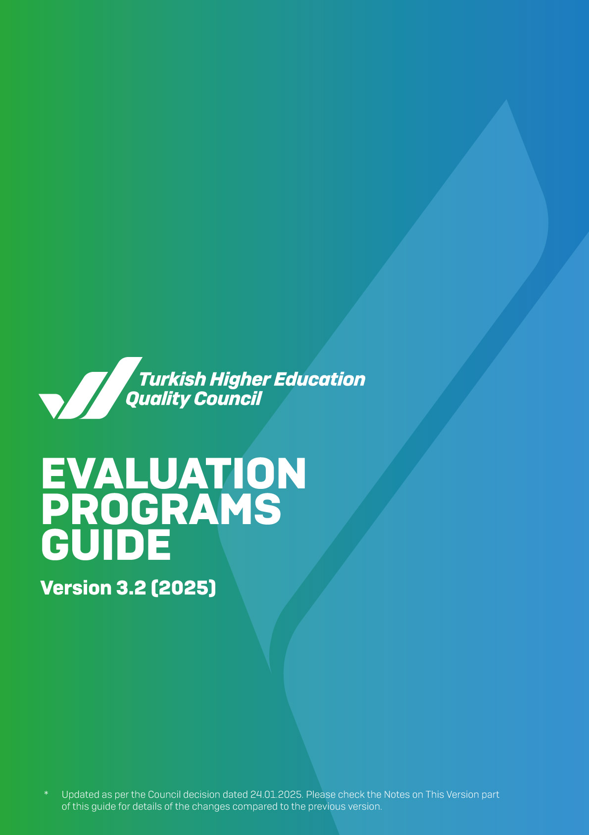
Table of Contents
FOREWORD 3
INTRODUCTION 4
A. INSTITUTIONAL EXTERNAL EVALUATION PROGRAM AND INSTITUTIONAL ACCREDITATION PROGRAM 4
A.1. DUTIES AND RESPONSIBILITIES OF THEQC COMMISSION ON INSTITUTIONAL EXTERNAL EVALUATION AND ACCREDITATION 8
A.2. DUTIES AND RESPONSIBILITIES OF THE EVALUATION TEAM 8
A.3. QUALIFICATIONS OF THE EVALUATION TEAM 9
A.4. METHODS TO BE USED BY EVALUATION TEAMS 10
A.5. COMMENCEMENT OF INSTITUTIONAL EXTERNAL EVALUATION AND INSTITUTIONAL ACCREDITATION PROGRAMS 11
B. EVALUATION PROCESS 12
B.1. PRE-EVALUATION THROUGH ISER(S) 12
B.1.1. Commencement of Pre-Evaluation Through ISERs 12
B.1.2. Planning the Site Visit Program 12
B.2. VISIT TO THE INSTITUTION 14
B.2.1. Pre-Visit 14
B.2.2. Site Visit 14
B.3. POST-VISIT ACTIVITIES 21
B.4. DECISION 23
B.5. APPEAL 24
B.6. PROCESS ASSESSMENT AND IMPROVEMENT 24
B.7. EXPENDITURES WITHIN THE EVALUATION PROCESS 24
B.8. INSTITUTIONAL FEEDBACK REPORT AND INSTITUTIONAL ACCREDITATION REPORT WRITING PRINCIPLES 25
C. FOLLOW-UP PROGRAM 25
C.1. GOAL AND SCOPE 25
C.2. METHOD 26
C.3. PROCESS 26
C.3.1. Preliminary Work 26
C.3.2. Site Visit 27
C.3.3. Follow-up Report 27
C.3.4. Approval and Publication 27
D. MID-TERM EVALUATION PROGRAM 28
D.1. GOAL AND SCOPE 28
D.2. METHOD 28
D.3. PROCESS 29
D.3.1. Preliminary Work 30
D.3.2. Site Visit 31
D.3.3. Mid-term Evaluation Report 31
D.3.4. Decision 31
ANNEXES 33
NOTES ON THIS VERSION 34
A. LEADERSHIP, GOVERNANCE AND QUALITY 41
B. LEARNING AND TEACHING 59
C.RESEARCH AND DEVELOPMENT 77
D. SERVICE TO SOCIETY 84

FOREWORD

The Turkish Higher Education Quality Council (THEQC) Evaluation Programs Guide has been issued to guide THEQC's internal and external stakeholders commissioned in the evaluation process of an HEI within Institutional External Evaluation Program, Institutional Accreditation Program, Follow-up Program or Mid-term Evaluation Program conducted by THEQC, considering the Standards and Guidelines for Quality Assurance in the European Higher Education Area (ESG-2015).

To realise the external evaluation programs objectively to contribute to the institution at the highest level:
i) Pre-visit preparations should be made fully and timely,
ii) Effective communication should be established with the institution during the visit, and
iii) Observation and evidence-based evaluations should be conveyed to the institution concisely and effectively, both in oral and written form.

Within the scope of external evaluation programs, an evaluation team qualitatively and quantitatively evaluates the institution's quality assurance system and the Leadership, Governance and Quality, Learning and Teaching, Research and Development, and Service to Society activities carried out in the institution. The reference documents to be used in the aforementioned evaluations are THEQC's Institutional External Evaluation Directive, the THEQC Evaluation Criteria, the Institutional Self-Evaluation Reports that HEIs submit to THEQC every year, and, if any, the feedback reports written after previous external evaluations of the institutions.

To contribute to the external evaluation programs of HEIs, all evaluators in the evaluation teams are expected to effectively communicate and cooperate with THEQC and adhere to academic ethical principles. Believing that external evaluation programs will be an important experience for institutions and evaluators, THEQC expects HEIs to manage continuous improvement efforts by establishing a strong internal quality assurance system.

INTRODUCTION
The Institutional External Evaluation Directive and the THEQC Evaluation Criteria, which will be taken as the basis for the evaluation programs, are available on the website of the Turkish Higher Education Quality Council (www.yokak.gov.tr). Under the aforementioned legislation, HEIs are obliged to write their annual institutional self-evaluation reports (ISERs) following the ISER Writing Guide available on THEQC's website and submit them to THEQC. The evaluators are expected to have a good command of the legislative documents, the criteria, and the most up-to-date version of the ISER Writing Guide, on which they will base their evaluation in the external evaluation programs.
THEQC describes its external evaluation programs as follows:
- Institutional External Evaluation Program (IEEP): HEIs, which graduated their first cohort of students, are compulsorily included in this program. In IEEP, teams evaluate them based on all THEQC Evaluation Criteria, and feedback is given through writing an Institutional Feedback Report (IFR) in which evaluation teams emphasise the areas for improvement.
- Follow-up Program (FuP): The HEIs evaluated under the IEEP are included in the FuP by THEQC in the second year at the earliest following their evaluation. In this process, the HEI is evaluated regarding the areas for improvement highlighted in the IFR, and feedback is provided through the Follow-up Report.
- Institutional Accreditation Program (IAP): After the completion of the IEEP and the FuP, HEIs are included in the IAP and evaluated based on the THEQC Evaluation Criteria. At the end of this process, an Institutional Accreditation Report (IAR) is written by the evaluation team.
- Mid-term Evaluation Program (MtEP): The HEIs, to which full or conditional accreditation was granted in the scope of the IAP are included in the Mid-term Evaluation Program in the second year after the accreditation decision at the earliest.

A. INSTITUTIONAL EXTERNAL EVALUATION PROGRAM AND INSTITUTIONAL ACCREDITATION PROGRAM
The IEEP and the IAP are two different external evaluation practices carried out by THEQC. The evaluation criteria and the processes regarding the formation of evaluation teams, pre-evaluation through ISERs, and pre-visit and site visits for IEEP and IAP are the same; however, the programs differ in terms of their outcomes. As a result of the IEEP, an Institutional Feedback Report (IFR), which highlights the areas for improvement, is written by the evaluation team and the report is shared with the public. As a result of the IAP, the evaluation team writes an institutional accreditation report (IAR). Based on this report, a full accreditation, conditional accreditation or refusal of accreditation decision is taken by THEQC and shared with the public.
HEIs evaluated within the scope of IEEP are included in the Follow-up Program (FuP) by THEQC in the second year following the evaluation year at the earliest. HEIs apply to the IAP no later than the fifth year following their IEEP process. HEIs that have not been evaluated within the scope of the FuP may not apply to the IAP. HEIs to be included in the IAP are selected by THEQC among the applicants in the relevant year. Among the HEIs evaluated in the scope of the FuP, those that do not apply to the IAP in five years following the IEEP, those whose accreditation validity periods have expired, and those for which refusal of accreditation/termination of accreditation is decided, are directly included in the IAP by THEQC at the end of the periods specified in this guide. Institutions previously evaluated in any external evaluation program may be re-evaluated if the Council deems it necessary.
The main features of the IEEP and the IAP are as follows:
- They are national evaluation programs registered and recognised by the European Quality Assurance Register for Higher Education (EQAR) and the European Association for Quality Assurance in Higher Education (ENQA).
- They include an evaluation based on the internal evaluation (self-evaluation) of an institution.
- They are evaluation programs that focus on contributing to the compliance of the institution's status with the mission/vision and strategic goals defined by itself, and adopt a "continuous improvement" approach.
- They include a peer review process in which the opinions of the internal and external stakeholders of the institution are taken.
- IARs and IFRs that include the feedback about the institution and decisions are published in the EQAR database and the Higher Education Institutions Exam (YKS) Guide.
In general, IEEP and IAP are designed to seek answers to the following questions:
- How an institution plans and manages the resources and competencies at hand within the processes of leadership, governance and quality, learning and teaching, research and development, and service to society in accordance with its values, mission and objectives,
- How an institution carries out the practices of follow-up and improvement as to the processes throughout the institution,
- How an institution ensures stakeholder involvement and inclusivity in planning, doing, checking and acting phases,
- What an institution's strengths and areas for improvement in its internal quality assurance system are,
- What the reasons for failed improvements are, and
- How an institution ensures sustainability in its quality assurance system to maintain its competitive advantage within the scope of the rapidly changing agenda of higher education.

THEQC carries out the external evaluation processes with 14 criteria and 46 sub-criteria with a holistic perspective under the headings of Leadership, Governance and Quality, Learning and Teaching, Research and Development, and Service to Society. The basic tool used in evaluation processes is the THEQC Rubric (Annex 1). The THEQC Rubric is a rubric-style assessment tool used in the self-evaluation works of higher education institutions and in writing institutional self-evaluation reports as well as in external evaluation processes; and developed to increase clarity, objectivity, comprehensibility, consistency, and transparency levels in external evaluation or decision-making processes.

The quality assurance process or mechanisms for each sub-criterion in the THEQC Rubric have been defined considering the maturity levels of the planning, doing, checking, and acting (PDCA) steps, and are rated on a scale of 1 to 5. The sub-criteria, whose maturity level is determined with this rubric, reveal the level of fulfilment of the relevant criteria. An example of the organisation of main headings, criteria and sub-criteria in the ISER Writing is presented in Diagram 1.
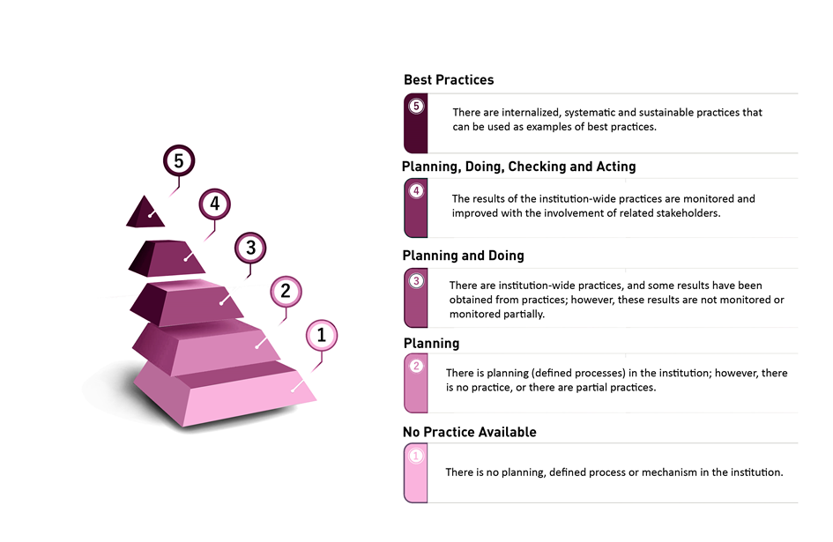

Diagram 1. Rating of the Maturity Levels of Sub-criteria via the THEQC Rubric

THEQC may carry out the Institutional External Evaluation Program and the Institutional Accreditation Program in the spring and/or fall terms. The annual calendar for the evaluation processes is given below:

Spring Term Calendar
Date | Description
January- February | Institutions to be evaluated are selected
January-March | Institutions write their Institutional Self-Evaluation Reports
March - April | Evaluator Training
April - May | Site visits are performed
June - July | - Institutional Feedback Reports are published as a part of the Institutional External Evaluation Program  - Institutional Accreditation Reports and the accreditation decisions are published in the scope of the Institutional Accreditation Program

Fall Term Calendar
Date | Description
January- February | Institutions to be evaluated are selected
January-March | Institutions write their Institutional Self-Evaluation Reports
September | Evaluator Training
October - November | Site visits are performed
December - January | - Institutional Feedback Reports are published as a part of the Institutional External Evaluation Program  - Institutional Accreditation Reports and the accreditation decisions are published in the scope of the Institutional Accreditation Program

A.1. DUTIES AND RESPONSIBILITIES OF THEQC COMMISSION ON INSTITUTIONAL EXTERNAL EVALUATION AND ACCREDITATION

Commission on Institutional External Evaluation and Accreditation (CoIEEA) is responsible for the execution and coordination of the IEEP and the IAP. The duties of CoIEEA in the related processes are as follows:
- Creating the evaluator pool,
- Carrying out the works to determine evaluator candidates and create evaluation teams,
- Planning and conducting the evaluator training,
- Planning and conducting training/information meetings for HEIs,
- Selecting the HEIs to be evaluated in the IEEP, IAP, FuP, and MtEP and submitting them to the Council,
- Giving feedback to the ISERs of higher education institutions,
- Checking the IFRs and draft IARs written by the evaluation teams for consistency and spelling,
- Presenting its opinion to the Council regarding the IAR written in the scope of the IAP,
- Writing the Higher Education Evaluation and Quality Assurance Status Report and submitting it to the Council.

A.2. DUTIES AND RESPONSIBILITIES OF THE EVALUATION TEAM
An Evaluation Team refers to the team assigned to evaluate a given higher education institution in the scope of external evaluation programs. The evaluation teams may include academic personnel, administrative staff, students, employers/sector representatives, and international experts. All team members, including student evaluators, have the same status.
Duties and Responsibilities of the Team Leader: The team leader refers to the member responsible for supervising the team assigned to carry out the external evaluation processes for a higher education institution. CoIEEA selects the team leader from the experienced evaluators in the evaluator pool and submits it to the Council for approval. The team leader fulfils the responsibilities specified in the Institutional External Evaluation Directive. In addition, s/he organises pre-visit and post-visit meetings regarding evaluation processes. S/he communicates with all relevant stakeholders during the evaluation process, and carries out the required controls for the performance of the visit as planned. The team leader also ensures that the examinations and evaluations carried out by the evaluators are carried out in accordance with the process specified in the Guide and that an objective and realistic evaluation is made within the scope of the Institutional External Evaluation and Accreditation Criteria. S/he is responsible for completion of reports written in the scope of the external evaluation programs.
Duties and Responsibilities of Evaluators: The evaluator refers to someone competent in external evaluation and assigned to an evaluation team. The evaluators are selected by the CoIEEA from the candidates in the evaluator pool considering the structure and size of the institution to be evaluated. Then, they are presented to the Council for approval. Evaluators carry out the examination and evaluation process based on the Institutional External Evaluation and Accreditation Criteria following the guide and contribute to the report writing process, using objective and evidence-based findings.
All Council and commission members and evaluators involved in the evaluation processes are required to sign the "The Statement of Confidentiality and Code of Ethics" given in the "Turkish Higher Education Quality Council Code of Ethics" document. This statement may also be obtained through the Quality Assurance Management Information System (QAMIS).

A.3. QUALIFICATIONS OF THE EVALUATION TEAM

All team members, who will take part in an evaluation process based on voluntary assignment, must attend and complete the evaluator training program. The parties must submit their statements if there is any conflict of interest between a team leader and the evaluation team members and the institution to be evaluated or not to THEQC within seven days via the QAMIS after the information related to the team members is conveyed to them.
Qualifications of evaluation team members are as follows:
- Experience in higher education and/or quality assurance in higher education,
- Adopting ethical principles,
- Being open to cooperation and teamwork,
- Having strong communication skills,
- Having time management and effective organisational skills.

The team leaders and evaluators should have knowledge about the THEQC Evaluation Criteria, communicate effectively with the institution managers/directors, employees, and students, respect the confidentiality of information about the individuals except team members in and out of the evaluation process, and evaluate the institution by avoiding comparing it with any other institution.

A.4. METHODS TO BE USED BY EVALUATION TEAMS
Methods to guide the evaluators in the evaluation processes can be grouped under four headings: document examination, observation, meeting/interview, and other methods (team debates, manager-director/employee/student comments, etc.).
Document Examination: The documents including the institution's vision, mission, strategic plan and priorities, activity, performance and self-check reports, the institution's ISERs, and external evaluation reports should be examined before the visit. It is expected that the evaluation team uses the document examination method effectively to have adequate information about the institution. If required, the evaluation team may request additional information and documents from the institution to be examined prior to the visit.
Observation: Issues such as the adequacy of academic and administrative units and shared areas, how the confidentiality and security of files and records are ensured, and how the backup and service provision (server) activities are carried out if the files are kept electronically, can be examined through observation during the visit.
Interview: During the visit, important findings can be obtained through one-to-one or focus group interviews along with the invited internal and external stakeholders of the institution. In this context, stakeholder meetings with the directors of the institution, academic and administrative staff, administrative unit representatives, for example, from the Registrar's Office and the Department of Personnel, students and the units from where students receive services (Department of Health, Culture and Sports, Department of Library and Documentation, Career Centre, Unit for Students with Disabilities, etc.) may be carried out.
Other Methods: Oral/written comments of the institution's staff and students, demonstration of various processes such as recruitment with implementation charts, the current institutional catalogue, introductory documents, the news about the institution, evidence regarding the interaction of the institution with internal and external stakeholders (projects, meetings, exhibition, etc.) or the use of methods such as examining activities within the scope of public relations also significantly contributes to the evaluation process.

A.5. COMMENCEMENT OF INSTITUTIONAL EXTERNAL EVALUATION AND INSTITUTIONAL ACCREDITATION PROGRAMS
The stages in the commencement of the Institutional External Evaluation Program and the Institutional Accreditation Program are below:
- Institutions are included in the IEEP no later than the fifth year after graduation of their first cohorts of students. Institutions that intend to be included in the IAP for the first time, apply with an official letter containing a statement of intent attached to the senate decision upon the invitation letter of THEQC. The institutional self-evaluation report written by the institution for the relevant year is subjected to a preliminary evaluation by CoIEEA in terms of compliance with the ISER Writing Guide. If the Commission approves the institution's eligibility for the external evaluation process, it is included in the list of institutions to be evaluated in that year’s IEEP or IAP.
- Under Article 5 and Article 6 of the Institutional External Evaluation Directive (IEED), for each institution to be included in the external evaluation program, CoIEEA creates an evaluation team with members whose number is determined considering the structure and size of the institution and submits it to the approval of the Council. After the approval of the Council, any mandatory changes that may be required in the teams to perform site visits are made by THEQC.
- Whether there is any conflict/coincidence of interest between the evaluation team and the institution included in the evaluation process is declared by the evaluators and the institution through the QAMIS. New evaluators are appointed to replace evaluators if there is a conflict/coincidence of interest. For the Institutional Accreditation Program, the Institutional Accreditation Program Agreement (Annex 6) is signed between the higher education institution and THEQC.

B. EVALUATION PROCESS

The evaluation process includes the activities related to the pre-evaluation through ISER(s), a two-stage visit to the institution, the oral presentation of the Exit Statement to the institution, the writing of the Institutional Feedback Report (IFR) for the Institutional External Evaluation Program after the visit, the writing of the Institutional Accreditation Report (IAR) for the Institutional Accreditation Program, and making an accreditation decision.

B.1. PRE-EVALUATION THROUGH ISER(S)
The pre-evaluation process through ISER(s) has two purposes:
- To be equipped with preliminary information about the institution before the site visit to the institution, and to ensure that the evaluation team is ready for the visit, and
- To form a plan for additional evaluations to be made during the site visit and additional information and documents to be requested from the institution before or during the visit.

B.1.1. Commencement of Pre-Evaluation Through ISERs
- The evaluation team can access the ISERs and the evidence provided by the institution to be evaluated through the QAMIS system.
- The evaluation team members examine the ISERs and their annexes to check to which extent they meet the requirements of the THEQC Evaluation Criteria. In case of unclear issues, information and documents may be requested from the institution to be evaluated.

B.1.2. Planning the Site Visit Program
- The team leader negotiates with the team members and the Rector/Director of the institution to be visited within the scope of the external evaluation process and determines a visit date suitable for all parties in April-May for the spring term and October-November for the fall term. Prior to the site visit, a pre-visit is performed by the evaluation team for the institution. The pre-visit is carried out remotely through an online platform provided by THEQC. As part of the pre-visit, meetings are held with institution managers/directors and the members of the Quality Commission. During the one-day pre-visit planned by the team leader and the Rector/Director of the related institution, the site visit program is also clarified.
- The team leader negotiates with the Rector/Director during or after the pre-visit and makes the necessary planning for the transportation of the team members and their accommodation in a suitable place close to the institution during the site visit. Accommodation facilities or a private meeting room in one of the institution's premises are provided by the institution for team meetings to be held during the site visit (Keeping the meeting room open for studies that might be extended until night and providing equipment such as computers, projectors and printers and also hot and cold drinks in the study room are expected).
- The team leader coordinates the creation of a draft program (Annex.2/b) for the site visit with the Rector/Director of the institution. The visit program is prepared within the scope of the THEQC Evaluation Criteria in a way to allow the institution to be comprehensively evaluated by the team and, at the same time, allow the institution to express itself effectively.
- The evaluators prepare the questions to be asked during the site visit by taking into account the criteria. They also determine the additional information to be requested from the institution and inform the team leader about them.
- The team leader and the evaluators exchange ideas for the preliminary evaluations of the additional information and documents required and all the details of the visit.
- The team leader communicates with the Rector/Director and requests additional information and documents, which might support the evaluation process at the beginning or during the visit, (if possible, during the pre-visit or before the site visit) to be sent to him.
- During the site visit, the selection of the units to be visited, and the issues related to the interviewees, namely the academic and administrative staff and students, are shared with the institution prior to the visit.
- In consultation with the Rector/Director, the team leader creates a final visit program and the visit dates are communicated to the Council via QAMIS. In addition, the dates for the site visit program are announced on the web page of the Council and the higher education institution.

B.2. VISIT TO THE INSTITUTION

B.2.1. Pre-Visit
It is a one-day visit by team members to the institution on an online platform, usually two or three weeks prior to the site visit. The pre-site visit (Annex.2/a) is carried out for the following purposes:
- The team members hold a meeting among themselves,
- The team members introduce themselves to the Rector/Director and senior management of the institution and hold the first meeting with them,
- The team members hold a meeting with the Quality Commission members in order to be briefed about the institution, and
- The site visit program is created by the team leader and the Rector/Director of the institution.

B.2.2. Site Visit
The site visit commences with the arrival of the evaluation team at the accommodation site and ends with the completion of all the meetings, the declaration of the Exit Statement verbally, and the team's departure.
The evaluation team conducts site visits for four goals:
- To evaluate the factors, which cannot be sufficiently explained in an ISER (for example, the academic environment, motivation of students and the staff, the level of academic staff and students' sense of belonging to the institution, the qualities of the staff and students, and similar factors),
- To help determine the strengths and areas for improvement of the institution,
- To examine the documents and information prepared and presented by the institution within the scope of the evaluation process, and to see the physical facilities on site,
- To contribute to the establishment of continuous improvement and quality culture in institutions with the "Exit Statement" to be declared at the end of the site visit.

The site visit should be carried out as a cluster of activities that are well integrated with each other. In order to clarify the process, the sample of an Evaluation Team's Site Visit Plan and the chronological activities within this scope are given in Annex.2/A. This plan should be considered only as an example, and the site visit plans should be rearranged for each team and institution to allow the realization of an effective evaluation. The duration of visits included in this guide may be increased by the evaluation team, if necessary, depending on the size of the institution. If necessary, meetings with the administrators of the institution (rector/director, chairperson of the board of trustees, senate, board of directors, quality commission, dean, etc.) may be held remotely through an online tool. These meetings may not be recorded under no circumstances.
In the selection of the academic units (faculty, institute, college, vocational school, research and application centre, etc.) and administrative units to be visited within the scope of the evaluation process, the size of the institution in terms of the number of students and employees and its strategic importance for the institution are taken into account. Attention is paid to the fact that the major fields of study (Science, Social, Medical and Health Sciences, Engineering, Education and Fine Arts) are included in the sample homogeneously according to the structure of the institution. Within the scope of the program, the "First Day Visit" is usually performed in the faculties, and the "Second Day Visit" in the institutes, schools and vocational schools.
In focus group discussions, attention should be paid to building rapport, not to having subordinate and superior relations between the participants, ensuring that the participants reflect the differences of the relevant focus group to provide more benefits to the institution, and inviting in only the pre-determined focus group members.
B.2.2.1. Evaluation Team's Arrival [Usually Sunday]
- Team members come together in the place of accommodation or at the meeting hall reserved for them in the institution and conduct the first team meeting of the visit. Discussions in the meeting focus on the following issues: [A minimum of three to four hours is recommended for the meeting.]
  - Revision of the works in the scope of the visit schedule pre-determined in cooperation with the institution by clearly expressing the timing and goal,
  - Ensuring consistency within the team regarding the evaluation of the institution by considering the THEQC Evaluation Criteria
  - Reviewing the potential questions to be raised by the team members related to the site visit schedule,
  - Sharing the contributions of the observers (if any) in the site visit activities with the evaluation team.
- The evaluation team, the Rector/Director, and other relevant persons from the institution to be invited by the Rector/Director come together in the evening (first meeting/dinner). After the first meeting, a general discussion is held regarding the site visit plan, and then views are exchanged.
B.2.2.2. The First Day [Usually Monday]
- The evaluation team conducts a short meeting with the Rector/Director. In the meeting, general approaches regarding leadership, quality and governance, learning and teaching, research and development, and service to society processes established by the institution, are discussed by taking into account the THEQC Evaluation Criteria. In addition, the issues related to the operation of the institution in the general framework that cannot be fully explained or clarified in the ISERs are put on the agenda by the team leader to be clarified. The Rector/Director also specifies the issues, if any, which he/she especially regards as a significant point during the site visit [Thirty-minute meeting is ideal for this].
- The evaluation team has a meeting with the Chairperson of the Board of Trustees at the Foundation Higher Education Institutions. [Forty-five-minute meeting is ideal for this].
- The evaluation team holds meetings with the institution's quality commission members. The quality commission prepares a presentation providing up-to-date information on several factors. These factors include the institution’s quality assurance system formed in line with the THEQC Evaluation Criteria, the role of the quality commission in the system and decision-making processes, the institution’s strategic objectives and the role of these objectives in regional/national development goals, the institution’s governance approach in the processes related to learning and teaching, research activities, service to society and administrative practices, the institution’s outlook on continuous improvement, the outcomes obtained in this scope, and other common aspects related to all units in the institution. After the presentation, a questions-and-answers session is held between the evaluation team and the commission members. [One-hour meeting is ideal for this.]
- The evaluation team meets with the members of the senate and the board of directors. In this meeting, the quality assurance system established by the institution taking into account the THEQC Evaluation Criteria, the strategic goals of the institution and the place of these goals in the regional/national development goals, the administrative approach of the institution in learning and teaching, research, service to society and governance processes, continuous improvement approach, and the results obtained within this scope are discussed. [One-and-a-half-hour meeting is ideal for this].
- Within the scope of the site visit, if it is necessary and appropriate for both parties (team/institution), the team may meet with the institution's officials at lunch to continue the discussions.
- In the afternoon, faculty visits take place. When deemed necessary, depending on the institution's size, the evaluation team can be divided into groups of a minimum of two people and simultaneously visit different academic units. During these visits, the dissemination of the quality processes to the unit(s), the objectives of the unit(s) and the place of these objectives in the strategic goals of the institution, the involvement of the stakeholders in the processes, the learning outcomes of the programs in the unit(s), activities within the scope of R&D and continuous improvement studies are discussed with the unit managers/directors (dean, assistant dean, faculty secretary). Evaluation team members raise issues that are not clearly understood about the operation of the unit(s) and ask for further clarification [Forty-five-minute meeting is ideal for this].
- Evaluation team members meet academic staff members of the faculty. Topics like the relationship of the academic staff with the governing body, their role in the quality assurance system, the recruitment procedures, staff development and motivation are all discussed during the meeting. The focus group of academic staff is expected to include a sufficient number of members (e.g., 8-10 people) and be inclusive enough to represent all parts of the faculty to ensure effective use of the planned time for the meeting [One-hour meeting is ideal for this].
- Evaluation team members come together with students in the faculty. The team ensures that guest students and international student representatives, if any, attend the meeting. In the meeting, students are asked to provide information based on their experiences on issues such as involvement in decision-making processes, quality assurance system, educational services and student support services. The group of students interviewed is expected to have an appropriate number (8-10 people) and be inclusive enough to represent all parts of the faculty to ensure effective use of the time planned for the meeting [One-hour meeting is ideal for this].
- The evaluation team conducts a meeting with the stakeholders of the higher education institution. Opinions of various institutions and organizations, non-governmental organizations and graduate representatives from the public and private sector, who are among the external stakeholders of the higher education institution, are taken into account. [One-and-a-half-hour meeting is ideal for this].
- After the first day's interviews, the evaluation team members come together for dinner and the following meeting. In the meeting, first, the summary of the day is made, and the first impressions are shared. In addition, the second day's task distribution is made. The duration of the meeting may vary depending on the number of members in the team and the number of units evaluated. The team leader chairs the discussions and meetings with effective time management. The first day's evaluator notes are compiled and recorded [The meeting might continue until late at night].
B.2.2.3. The Second Day [Usually Tuesday]
- The site visits are performed at the units selected among the institutes, schools and vocational schools of the institution. When deemed necessary, depending on the institution's size, the evaluation team can be divided into groups of a minimum of two people and simultaneously visit different academic units. During the visits, the team holds meetings with managers/directors to have information on the dissemination of quality processes to the unit(s), the objectives of the unit(s) and the place of these objectives in the strategic goals of the institution, the involvement of stakeholders in the processes, the learning outcomes of the programs within the units, and continuous improvement works. Evaluation team members raise issues that are not clearly understood regarding the operation of the unit(s) and may ask for clarification [Forty-five-minute meeting is ideal for this].
- Evaluation team members meet the academic staff of the relevant unit. At the meeting, issues such as the relationship of academic staff with senior management, the role of the quality assurance system in the activities of teaching staff, the recruitment of the new staff, and the policies related to the development and motivation of the academic staff are discussed. The interviewed academic staff group is expected to have an appropriate number (8-10 people) to ensure the effective use of the planned time for the meeting and to make sure that all parties of the academic unit are represented. [One-hour meeting is ideal for this].
- The evaluator group meets the students of the relevant unit. The team ensures that guest students and international student representatives, if any, attend the meeting. In the meeting, students are asked to provide information based on their experiences on issues such as involvement in decision-making processes, quality assurance system, educational services and student support services. The group of students interviewed is expected to have an appropriate number (8-10 people) and be inclusive enough to represent all parts of the faculty to ensure effective use of the time planned for the meeting [One-hour meeting is ideal for this].
- The evaluation team meets at the lunch break (meeting/lunch).
- The evaluation team meets the managers of the administrative units (Personnel Department, Health, Culture and Sports Department, Registrar's Office, Library and Documentation Department, Career Centre, Disabled Student Unit, etc.), and exchanges information on the dissemination of quality processes to the units, the objectives of the unit(s) and the place of these objectives in the strategic goals of the institution, the involvement of stakeholders in the processes, and continuous improvement efforts. The evaluation team raises unclear issues regarding the operation of the units and asks for further clarification [One-hour meeting is ideal for this]. After the interviews, the evaluators may visit some selected units in groups.
- Evaluation team members meet administrative staff in relevant administrative units. Issues such as the relations of the administrative staff with the management, their role in the quality assurance system, the professional development and motivation of the administrative staff, and in-house communication are discussed at the meeting [One-hour meeting is ideal for this].
- The evaluation team holds meetings with the research unit(s) (Research and Application Centres, Technocity, Technology Transfer Offices, etc.) and their managers to evaluate the research and development activities in the institution . The units' objectives, the role of these objectives in the institution's strategic goals, stakeholder involvement in the processes, quality processes, and continuous improvement works are discussed. Evaluation team members raise issues that are not clearly understood about the unit(s)' operation and ask for further clarification. [Ninety-minute meeting is ideal for this.]
- After the second day's interviews, the evaluation team members come together at dinner and the following meeting. In the meeting, preparations are carried out for the Final Meeting, which will be the last event of the institutional external evaluation visit. Team leader writes the Exit Statement (Annex 3) to be presented verbally at the Final Meeting, with the contribution of the evaluators. The exit statement covers the institution's strengths, the processes whose improvement process has been launched but has not yet been completed, the areas for improvement, and explanations about these issues. Any area for improvement should be explained briefly and precisely. Observations and suggestions for improvement may also be included in the exit statement. The issues to be specified in the Exit Statement are carefully worded to contribute to the development and improvement of the institution [The meeting may continue until late at night to complete the Exit Statement].
B.2.2.4. The Third Day [Usually Wednesday]
- The evaluation team holds a brief meeting with the Rector/Director regarding the overall external evaluation process. In the meeting, the team leader shares the findings regarding the strengths and areas for improvement with the Rector/Director and shares the issues related to the operation of the units. The team leader reminds the Rector/Director to fill in the online form, the "Higher Education Institution's Assessment Form for the Evaluation Team", developed by the Turkish Higher Education Quality Council, which includes information about the quality of the visit and evaluations about the team members, within five working days on the QAMIS upon completion of the visit [Forty-five-minute meeting is ideal for this].
- The evaluation team conducts a "Final Meeting" with the Rector/Director and the officials working at the institution, such as vice-rectors, deans, directors, quality commission members, other managers, etc . The Exit Statement that emphasises the institution’s strengths and areas for improvement is delivered orally at the Final Meeting. To increase the contribution of the Final Meeting to the institution, it is recommended that comprehensive participation in the meeting should be ensured. At the end of the meeting, if there are questions from the institution's administrators, a short questions-and-answers session may also be held. The final meeting is jointly concluded by the Rector/Director and the team leader [One-and-a-half to a two-hour meeting is ideal for this].
- Upon the completion of the Final Meeting, the evaluation team leaves the institution.
- During and after the final meeting, the evaluation team may not ask for additional evidence and documents. After this stage, any additional evidence and documents submitted by the institution to the evaluation team will not be considered in the evaluation.
- The evaluation team is expected, within five (5) working days after the end of the visit, to fill in the "Form for Team Members' Evaluation" on QAMIS to evaluate the team leader and their team members.

B.3. POST-VISIT ACTIVITIES
The post-visit activities start with the completion of the site visit. It ends with the approval and publication of the IFR for the Institutional External Evaluation Program by THEQC, and the approval of IAR by THEQC for the Institutional Accreditation Program and the publication of the accreditation decision based on this report.
Post-visit activities serve three purposes:
- Ensuring that the findings of the visit and the evaluations to be made by the institution are included in the IFR/IAR to be submitted to the institution,
- Ensuring that the institution is given opportunity to express further opinion, and
- Ensuring consistency between evaluations for a specific criterion in evaluations performed in different institutions in the same evaluation period.
The post-visit process should be carried out as a group of activities that are well integrated with each other. The activities to be carried out within the scope of the process are given below in chronological order. The specified time is the number of days starting from the completion of the site visit to the completion of all works. During the process, all correspondence and forms are made electronically.

After the site visit:
The evaluation team submits the draft report, including the feedback results, to THEQC through QAMIS within 15 days after the site visit. THEQC conducts a preliminary review of the report within ten (10) days in terms of completeness, consistency between the text and the assigned maturity levels, clarity, and language. Correction suggestions, if any, are forwarded to the evaluation team and the team implement the suggestions they approve within ten (10) days.
- The evaluation team leader submits the pre-reviewed draft report to the institution via the QAMIS, and the institution submits the feedback results to the team leader within 15 days.
- The institution sends the feedback to the team leader through QAMIS. In its response, the institution may only express an opinion on the areas for improvement specified in the draft report and the correction of factual errors, if any.
- The team leader communicates with the evaluators in the evaluation team and updates the report on QAMIS, using the institution's feedback and data, and sends it to THEQC (within 10 days following the institution's response).
- If the team does not receive any response within 10 days, it will be deemed that all evaluations in the report are accepted by the institution and the right to ask for correction is waived.
- In order to ensure consistency between evaluations conducted in different institutions in the same evaluation period and between years, the consistency checks for the draft reports are carried out by the CoIEEA.
- After the consistency checks by CoIEEA, the final IFR/IAR is submitted to the Council for approval.
- The final IFR/IAR is sent to the institutions by THEQC as an attachment to an official letter and is published on the web page of THEQC and the relevant institution, thereby presenting it to the public. In addition, the decision made by THEQC regarding the Institutional Accreditation Program and the accreditation decision letter are forwarded to the institution. The reports are announced on THEQC's website and DEQAR.

B.4. DECISION
When the evaluation of higher education institutions within the scope of the Institutional Accreditation Program is completed, an accreditation decision is made by THEQC, taking into account the IAR written by the evaluation team. In the IAP to be carried out within the scope of the THEQC Evaluation Criteria, the evaluation will be based on the following grading system:
- 300 points for Leadership, Governance and Quality heading,
- 400 points for Learning and Teaching heading,
- 200 points for Research and Development heading, and
- 100 points for Service to Society heading, totalling up to 1.000 points.
The maturity level of each sub-criterion will be determined by the evaluation team within the scope of the Institutional Accreditation Program, and the general approach to the maturity level of the sub-criteria is as follows: In the evaluation, the maturity level of "5" corresponds to the full score, and the maturity level of "1" corresponds to the lowest score. The Institutional Accreditation Program's Score Chart is present in Annex 4.
As a result of the maturity level evaluation of the sub-criteria under every criterion within the scope of the Institutional Accreditation Program by THEQC, the following decisions can be made:
- "Full accreditation" is awarded if the score is 650 and above,
- "Conditional accreditation" is awarded if the score is between 500 and 649 points, or
- “Refusal of accreditation” is decided if the score is less than 500 points.
Full accreditation is granted for a five-year period, and conditional accreditation is granted for a two-year period. A conditional accreditation decision is made on a one-off basis for an institution. The HEIs for which a refusal of accreditation decision is given within the IAP as their scores were below 500 points may reapply at the earliest in the second year after this decision. HEIs with scores below 280 points in the Learning and Teaching heading may not be awarded full accreditation even if their total score is 650 or above, resulting in the award of conditional accreditation (as featured in the IAP for the first time). With the accreditation decision as a result of IAP, an Accreditation Decision Letter that THEQC writes by including the issues for further quality development is submitted to the institution in an official letter.

B.5. APPEAL
Higher education institutions may lodge appeals against the outcomes of the Institutional External Evaluation Program and Institutional Accreditation Program processes carried out by THEQC. Appeal and complaint processes are executed as per the “Turkish Higher Education Quality Council Directive on Appeals and Complaints”.

B.6. PROCESS ASSESSMENT AND IMPROVEMENT
A 360-degree evaluation approach is used in evaluation processes, in which the team members involved in the evaluation processes evaluate each other, and the institution's director evaluates the team members. For this, the forms on the QAMIS are filled in by the evaluators and the institution within five working days following the evaluation; thus, they are submitted to the Turkish Higher Education Quality Council.
In addition, the parties involved in the process are expected to evaluate the activities in all three phases of the process (pre-, during, and post-visit) and to submit their suggestions for improvement in written form to the Turkish Higher Education Quality Council.
When the evaluation process is completed each year, two separate evaluation meetings are held with the team leaders and the managers/directors of higher education institutions that have been involved in the external evaluation process for the relevant year. In addition, an information-sharing meeting is held for all higher education institution representatives in relation to all feedback and evaluations for that year.
According to the relevant article of the Regulation on Higher Education Quality Assurance and the Turkish Higher Education Quality Council, the Higher Education Evaluation and Quality Assurance Status Report is written by the Institutional External Evaluation and Accreditation Commission and then delivered to all stakeholders.

B.7. EXPENDITURES WITHIN THE EVALUATION PROCESS
All kinds of expenditures regarding the evaluation processes to be carried out in Higher Education Institutions are covered by the relevant budget of the higher education institution, the external evaluation process of which is being carried out.

B.8. INSTITUTIONAL FEEDBACK REPORT AND INSTITUTIONAL ACCREDITATION REPORT WRITING PRINCIPLES
The team leader is responsible for writing the IFR and the IAR. However, one of the members may be appointed as a minute-taker for task-sharing purposes among team members and to support the team leader in writing the report. Reports are created on QAMIS. The points to be considered in the writing of IFR and IAR are explained below:
- Accuracy: It is important to use correct and appropriate terms in report writing. Concepts should be used as they are in the legislation. In addition, the definitions and terms, such as faculty, department, main academic discipline, commission, and the course names within the institution should be used accordingly.
- Impartiality: Findings of the evaluation and the conclusions made as a result of the evaluation should be reflected without exaggeration, distortion or criticism.
- Evidence-Based Approach: Evaluations should be supported by evidence, away from assumptions or personal opinions.
- Format: A format set for the THEQC Evaluation Criteria should be followed at every stage of the report writing. It is recommended that the Institutional Feedback Reports be written in 25-30 pages, and Institutional Accreditation Reports in 40-50 pages following the format on the QAMIS.
- Style: Constructive criticism should be included in the report, and expressions that will contribute to the development of the institution should be used.
- Turkish Grammar and Spelling Rules: Grammar and spelling rules should be considered in report writing, and complicated linguistic structures should be avoided. A clear and concise language should be preferred.

C. FOLLOW-UP PROGRAM

C.1. GOAL AND SCOPE

Higher education institutions whose evaluation is completed within the scope of the Institutional External Evaluation Program carried out by THEQC are included in the Follow-up Program in the second year at the earliest.
The purpose of the Follow-up Program is to evaluate the development process in a higher education institution after the external evaluation process. The main evaluation scope of the Follow-up Program consists of the areas for improvement mentioned in the Institutional Feedback Reports, the output of the institution's external evaluation. Additionally, whether the strengths of the institutions stated in the IFRs are sustainable is evaluated within the scope of the Follow-up Program.

C.2. METHOD

The Follow-up Program is carried out through the follow-up teams to be established by THEQC. A follow-up team consists of at least three evaluators. One of them is selected among the previously commissioned team leaders and the other(s) from the evaluators' pool. The evaluators in the follow-up team should not have any conflict/coincidence of interest with the HEI to be included in the follow-up process. If deemed necessary by THEQC, training can be given to those who will take part in the follow-up team.

C.3. PROCESS

The activities and processes within the scope of the Follow-up Program are carried out as specified in the following stages:
  - Announcement of higher education institutions to be included in the follow-up process,
  - Establishment of follow-up teams (if necessary, training is given before the teams are formed),
  - Receiving statements regarding the absence of any conflict or coincidence of interest between the relevant higher education institutions and the follow-up team members via QAMIS,
  - Evaluation of documents (via ISERs and IFR) by the follow-up team and request of information and documents from the relevant higher education institution,
  - Paying a one-day site visit by the follow-up team to the higher education institution involved in the follow-up process (the visit may be face-to-face or remotely via an online platform),
  - Writing of the Follow-up Report by the follow-up team and submitting it to THEQC,
  - Checking the consistency and spelling of the report,
  - Publication of the report on the THEQC website and DEQAR.

C.3.1. Preliminary Work

In the preliminary work phase, the follow-up team examines the ISERs written by a higher education institution and the IFR written within the scope of the Institutional External Evaluation Program. The follow-up team may also request additional information and documents from the higher education institution to eliminate any possible ambiguity within the text.

C.3.2. Site Visit

In the site visit phase, a one-day site visit is paid to the higher education institution by the follow-up team. Within the scope of the site visit, meetings are held with the rector/director of the higher education institution, the chairperson of the board of trustees (for foundation higher education institutions), the senate, and the members of the quality commission. Within the scope of the Follow-up Program, a presentation including improvement works is held by the rector/director of the institution at a meeting with the senate/council members. The sample site visit schedule prepared within the scope of the Follow-up Program is given in Annex 5.

C.3.3. Follow-up Report

In the Follow-up Report writing stage, a Follow-up Report is written by the follow-up team on QAMIS. Within 15 days following the completion of the site visit, the Follow-up Report is written by the follow-up team and then forwarded to THEQC. The follow-up report includes evaluations on the following issues:
- Improvement practices carried out in the institution regarding the areas for improvement specified in the IFR,
- If there are no improvement practices regarding areas for improvement, the reasons for them,
- Whether the sustainability of the strengths in the IFR is provided,
- Evaluations carried out by the follow-up team, except for the matters included in the IFR.

C.3.4. Approval and Publication

In the approval and publication phase, after the consistency and spelling checks are made on the follow-up report by the Commission on Institutional External Evaluation and Accreditation, the report is submitted to the Council. After the approval of the Council, the report is published on the THEQC website and sent to the relevant higher education institution.

D. MID-TERM EVALUATION PROGRAM

D.1. GOAL AND SCOPE

HEIs whose IAP evaluations are ended with the grant of full or conditional accreditation are included in the Mid-term Evaluation Program in the second year following the accreditation decision taken for them. The mid-term evaluation aims to assess the development of quality processes in HEIs for which full or conditional accreditation was granted.

HEIs that are granted full accreditation are subject to mid-term evaluation at the earliest in the second year following the grant of accreditation. An evaluation team pays an online site visit to fully-accredited institutions involved in the mid-term evaluation process to assess the current status of the areas for improvement suggested in the IAR and accreditation decision letter. If deemed necessary by the Council, the site visit may also be conducted face-to-face. The mid-term evaluation of HEIs holding conditional accreditation is carried out following the IAP process steps.

Full accreditation is granted to the institutions that meet the related criteria as a result of the mid-term evaluation. Otherwise, the institution's accreditation is terminated. Institutions whose accreditation is terminated are included in the IAP in the second year following this decision.

D.2. METHOD

An evaluation team executes the method to be applied in the mid-term evaluation process, considering the accreditation decision taken after the IAP.

A mid-term evaluation team is formed for the institutions holding conditional accreditation as specified in the IAP. For fully-accredited institutions, the mid-term evaluation team consists of at least four evaluators. One of them is selected among those who previously served as team leader, preferably among those who took place in the institution's previous IAP evaluation process. The evaluators in the mid-term evaluation team should not have any conflict/coincidence of interest with the higher education institution to be included in the mid-term evaluation process.

D.3. PROCESS

The activities to carry out and the procedures to follow in the institutions for which site visit is necessary in the scope of mid-term evaluation are as follows:

- Announcement of higher education institutions to be included in the mid-term evaluation process,
- Formation of mid-term evaluation teams,
- Receiving statements regarding the absence of any conflict or coincidence of interest between the relevant higher education institution and the mid-term evaluation team members via QAMIS,
- Evaluation of the related documents (post-IAP ISERs, IAR, and Accreditation Decision Letter, etc.) by the mid-term evaluation team and request of information and documents from the relevant higher education institution, if needed,
- The site visit is carried out in the following steps for conditional accreditation and full accreditation:
  - A mid-term evaluation team conducts a site visit to an HEI holding conditional accreditation and included in the MtEP, following the site visit schedule set for the IAP.
  - A mid-term evaluation team conducts a one-day, online site visit to an institution holding full accreditation and included in the MtEP; the site visit may be face-to-face according to the Council decision.
- The Mid-term Evaluation Reports are written after the evaluation, considering the types of accreditation, conditional or full:
  - For an HEI with conditional accreditation and included in the MtEP, the team writes a report according to the IAR format.
  - For an HEI with full accreditation and included in the MtEP, the team writes a report focusing on the areas for improvement specified in the IAR and accreditation decision letter.

- The evaluation team submits the draft report, including the feedback results, to THEQC through QAMIS within 15 days after the site visit. THEQC conducts a preliminary review of the report within ten (10) days in terms of completeness, consistency between the text and the assigned maturity levels, clarity, and language. Correction suggestions, if any, are forwarded to the evaluation team and the team implement the suggestions they approve within ten (10) days.
- The evaluation team leader submits the pre-reviewed draft report to the institution via the QAMIS, and the institution submits the feedback results to the team leader within 15 days.
- The institution sends the feedback to the team leader through QAMIS. In its response, the institution may only express an opinion on the areas for improvement specified in the draft report and the correction of factual errors, if any.
- The team leader communicates with the evaluators in the evaluation team and updates the report on QAMIS, using the institution's feedback and data, and sends it to THEQC (within 10 days following the institution's response).
- In order to ensure consistency between evaluations conducted in different institutions in the same evaluation period and between years, the consistency checks for the draft reports are carried out by the CoIEEA.
- The decision suggestion based on the MtER whose consistency check is made by CoIEEA is presented to the Council. The mid-term evaluation decision is sent to the institutions by THEQC as an attachment to an official letter and is published on the web page of THEQC and the relevant institution, thereby presenting it to the public.
In addition, THEQC's IAP decision, accreditation decision letter and MtER are sent to the institution. These documents are published on THEQC's website and DEQAR.

D.3.1. Preliminary Work

In the preliminary work phase, the mid-term evaluation team examines the post-IAP ISERs of a higher education institution included in the process of the mid-term evaluation, which will constitute a base to evaluate the institution's improvement level in line with the IAR written by the IAP evaluation team and the Accreditation Decision Letter sent by the Council. The mid-term evaluation team may request additional information and documents from the higher education institution to assist the evaluation process and clarify the uncertainties.

D.3.2. Site Visit

A mid-term evaluation team visits an institution with conditional accreditation and in the mid-term evaluation process, following the IAP site visit schedule. On the other hand, a mid-term evaluation team conducts a one-day, online site visit to an institution with full accreditation and in the mid-term evaluation process. The focus groups to be interviewed within the scope of the site visit are determined by the mid-term evaluation team, taking into account the IAR and the accreditation decision letter.

D.3.3. Mid-term Evaluation Report

For an institution with conditional accreditation and included in the mid-term evaluation process, a report is written by a mid-term evaluation team in accordance with the IAR format. For an institution with full accreditation and included in the mid-term evaluation process, a report is written following a format created to focus on the areas for improvement specified in the accreditation decision letter.
The MtER for institutions with conditional accreditation written by covering all sub-criteria as in the IAR.

A Mid-term Evaluation Report covers the following:
- Improvement work carried out in the institution regarding the areas for improvement specified in the IAR and the Accreditation Decision Letter,
- If there are no improvement efforts in areas for improvement, the findings, including the reasons for these, are handled for follow-up purposes.

D.3.4. Decision

The Council makes the accreditation decision in MtEP, considering the recommendation of the Commission on Institutional External Evaluation and Accreditation based on the MtER written by the evaluation team.
For the HEIs with full accreditation, it is decided to publish the report and continue accreditation within the scope of the mid-term evaluation process. The Council reserves the authority to initiate a new evaluation process when deemed necessary.
Accreditation decisions after the mid-term evaluation for HEIs with conditional accreditation can be taken as follows:
- The conditional accreditation of an HEI that proved to be entitled to full accreditation as a result of the mid-term evaluation, is upgraded to full accreditation (2 years + 3 years),
- The refusal of accreditation decision is taken for an HEI that cannot maintain the criteria of full accreditation based on the MtER written as a result of the mid-term evaluation.
The Council shares the Mid-term Evaluation Reports and the accreditation decisions for the higher education institutions, written as outputs of the Mid-term Evaluation Program, with the public.
An HEI for which a refusal of accreditation decision was made may reapply to the IAP at the earliest in the second year after this decision.

ANNEXES

- The THEQC Rubric
- A- Sample Pre-Visit Schedule for Evaluation Teams – IEEP/IAP/MtEP[For Use in Conditionally Accredited HEIs]
B- Sample Site Visit Schedule for Evaluation Teams – IEEP/IAP/MtEP[For Use in Conditionally Accredited HEIs]
- Exit Statement Template
- Institutional Accreditation Program's Score Chart
- A-Sample Visit Schedule for Follow-up Teams
B-Sample Site Visit Schedule for Mid-term Evaluation Teams [For Use in Fully-Accredited HEIs]
- Institutional Accreditation Program Agreement

NOTES ON THIS VERSION

Comparison Chart for the Changes in Evaluation Programs Guide Version 3.2.

Previous Version (3.1) | Up-to-date Version (3.2)
Follow-up Program (FuP): The HEIs evaluated under the IEEP are included in this program after two years. The HEI is evaluated considering the areas for improvement in the IFR, which results in the writing of a Follow-up Report. | Follow-up Program (FuP): The HEIs evaluated under the IEEP are included in the FuP by THEQC after two years in the second year at the earliest following their evaluation and. In this process, the HEI is evaluated regarding the areas for improvement highlighted in the IFR, and feedback is provided through the Follow-up Report. (p.3)
The higher education institutions evaluated within the scope of the Institutional External Evaluation Program apply to the Institutional Accreditation Program conducted by the Council at the latest in the fifth year following this evaluation. The higher education institutions that have not been evaluated within the scope of the Follow-up Program do not apply to the Institutional Accreditation Program. The higher education institutions to be included in the Institutional Accreditation Program are selected by THEQC among the applicants of that year. Out of the higher education institutions that have been evaluated within the scope of the IEEP and FuP, the ones that have not applied to the IAP within five years following the IEEP are included in the IAP directly by THEQC. | Among the HEIs evaluated in the scope of the Institutional External Evaluation Program and FuP, those that do not apply to the Institutional Accreditation Program IAP in five years following the Institutional External Evaluation Program IEEP, those whose accreditation validity periods have expired, and those for which refusal of accreditation/termination of accreditation is decided, are directly included in the Institutional Accreditation Program IAP by THEQC at the end of the periods specified in this guide. Institutions previously evaluated in any external evaluation program may be re-evaluated if the Council deems it necessary. (p.4)
They have a nationwide evaluation process benefitting from an internationally accepted perspective. | They a have a nationwide evaluation process benefitting from an internationally accepted perspective are national evaluation programs registered and recognised by the European Quality Assurance Register for Higher Education (EQAR) and the European Association for Quality Assurance in Higher Education (ENQA). (p.4)
The institutional self-evaluation report written by the higher education institution, which expressed its interest in being included in the evaluation process, for that year is subjected to a preliminary evaluation by CoIEEA in terms of compliance with the ISER Writing Guide. If the Commission approves the institution's eligibility to enter the external evaluation process, it is included in the list of institutions to be evaluated in that year’s IEEP or IAP. | 1. The institutional self-evaluation report written by the higher education institution, which expressed its interest in being included in the evaluation process, for that year Institutions are included in the IEEP no later than the fifth year after graduation of their first cohorts of students. Institutions that intend to be included in the IAP for the first time, apply with an official letter containing a statement of intent attached to the senate decision upon the invitation letter of THEQC. The institutional self-evaluation report written by the institution for the relevant year is subjected to a preliminary evaluation by CoIEEA in terms of compliance with the ISER Writing Guide. If the Commission approves the institution's eligibility for the external evaluation process, it is included in the list of institutions to be evaluated in that year’s IEEP or IAP. (p.10)
Under Article 5 and Article 6 of the Institutional External Evaluation Directive (IEED), for each institution to be included in the external evaluation program, CoIEEA creates an evaluation team with members whose number is determined considering the structure and size of the institution, updates it when necessary, and submits it to the approval of the Council. | 2. Under Article 5 and Article 6 of the Institutional External Evaluation Directive (IEED), for each institution to be included in the external evaluation program, CoIEEA creates an evaluation team with members whose number is determined considering the structure and size of the institution, updates it when necessary, and submits it to the approval of the Council. After the approval of the Council, any mandatory changes that may be required in the teams to perform site visits are made by THEQC. (p.10)
 | Taking into account the feedback received from the evaluators and institutions, CoIEEA matches the evaluation teams and the institutions to be evaluated in a way that does not cause any conflict/coincidence of interest. (p.11)
In focus group discussions, attention should be paid to building rapport, not to having subordinate and superior relations between the participants, to provide more benefits to the institution and ensure that the participants reflect the differences of the relevant focus group. | In focus group discussions, attention should be paid to building rapport, not to having subordinate and superior relations between the participants, ensuring that the participants reflect the differences of the relevant focus group to provide more benefits to the institution, and inviting in only the pre-determined focus group members. (p.14)
 | 4- During and after the final meeting, the evaluation team may not ask for additional evidence and documents. After this stage, any additional evidence and documents submitted by the institution to the evaluation team will not be considered in the evaluation. (p.20)
- The evaluation team submits the draft report containing the feedback results to the institution via the QAMIS within 21 days after the visit and asks it to submit feedback about the report to the team leader within 21 days.  - The institution sends the "21-day response" to the team leader over QAMIS. In this response, the institution may only express an opinion on the aspects of the draft report about the areas for improvement and the correction of mistakes of facts, if any.  - The team leader communicates with the evaluators in the evaluation team and updates the report over QAMIS, using the data in the “21-day response” of the institution, and sends it to THEQC (within 21 days following the response of the institution).  - In order to ensure consistency between evaluations conducted in different institutions in the same evaluation period and between years, the consistency checks for the draft reports are carried out by the CoIEEA.  - After the consistency checks, the final IFR/IAR is created by CoIEEA, and this report is submitted to THEQC for approval.  - The final IFR/IAR is sent to the institutions by THEQC as an attachment to an official letter and is published on the web page of THEQC and the relevant institution, thereby presenting it to the public. In addition, the decision made by THEQC regarding the Institutional Accreditation Program is also forwarded to the institution and announced on the website. | 1) The evaluation team submits the pre-reviewed draft report, including the feedback results, to the institution THEQC through QAMIS within 2115 days after the visit site visit. THEQC conducts a preliminary review of the report within ten (10) days in terms of completeness, consistency between the text and the assigned maturity levels, clarity, and language. Correction suggestions, if any, are forwarded to the evaluation team and the team implement the suggestions they approve within ten (10) days.  1) 1. The evaluation team leader submits the pre-reviewed draft report to the institution via the QAMIS, and the institution submits the feedback results to the team leader within 2115 days.  2) 2. The institution sends the “21-day response” feedback to the team leader through QAMIS. In its response, the institution may only express an opinion on the areas for improvement specified in the draft report and the correction of factual errors, if any.  3) 3. The team leader communicates with the evaluators in the evaluation team and updates the report on QAMIS, using the institution's “21-day response” feedback and data, and sends it to THEQC (within 2110 days following the institution's response).  - If the team does not receive any response within 10 days, it will be deemed that all evaluations in the report are accepted by the institution and the right to ask for correction is waived.  4) 5. In order to ensure consistency between evaluations conducted in different institutions in the same evaluation period and between years, the consistency checks for the draft reports are carried out by the CoIEEA.  5) 6. After the consistency checks by CoIEEA, the final IFR/IAR is created by CoIEEA, and this report is submitted to the Council for approval.  6) 7. The final IFR/IAR is sent to the institutions by THEQC as an attachment to an official letter and is published on the web page of THEQC and the relevant institution, thereby presenting it to the public. In addition, the decision made by THEQC regarding the Institutional Accreditation Program and the accreditation decision letter are forwarded to the institution. The reports are announced on THEQC's website and DEQAR. (p.21)
Full accreditation is granted for a five-year period, and conditional accreditation is granted for a two-year period. The higher education institutions for which a refusal of accreditation decision is given within the IAP as their scores were below 500 points may reapply at the earliest two years after this decision. Higher education institutions that fail to get 280 points out of 400 points in the Learning and Teaching heading may not be awarded full accreditation even if their total score is 650 or above, resulting in the award of conditional accreditation. With the accreditation decision as a result of IAP, an Accreditation Decision Letter that THEQC writes by including the issues for further quality development is submitted to the institution in an official letter. | Full accreditation is granted for a five-year period, and conditional accreditation is granted for a two-year period. A conditional accreditation decision is made on a one-off basis for an institution. The HEIs for which a refusal of accreditation decision is given within the IAP as their scores were below 500 points may reapply at the earliest two years after in the second year after this decision. HEIs that fail to get 280 points out of 400 points with scores below 280 points in the Learning and Teaching heading may not be awarded full accreditation even if their total score is 650 or above, resulting in the award of conditional accreditation (as featured in the IAP for the first time). (p.22)
Higher education institutions may lodge appeals against the outcomes of the Institutional External Evaluation Program and Institutional Accreditation Program processes carried out by THEQC. The appeals against the IFR published within the scope of the Institutional External Evaluation Program can be made within 60 days from the date of publication and against the IAR and the accreditation decision within the scope of the Institutional Accreditation Program within 60 days.  Appeals are lodged with the Commission on Appeals and Complaints within the scope of the “Turkish Higher Education Quality Council Directive on Appeals and Complaints”. Appeals are lodged either in written form or electronically, supported with appropriate justification and evidence. Appeals are subject to preliminary review within seven days by the Commission Secretariat. As a result of the preliminary review, the appeals lodged without providing appropriate justification and evidence are rejected. The appeals which have not been rejected are forwarded to the Commission within seven days following the preliminary review. The appeals submitted to the Commission are reevaluated and submitted to the Council within 30 days at the latest. The Commission may meet the parties if needed. The Commission includes advisory opinions on the acceptance or rejection of an appeal. The final decision on appeals is made by the Council, considering the advisory opinion of the Commission. Appeals approved by the Commission on Appeals and Complaints are forwarded to THEQC for re-assessment. The final decision is submitted in writing to the person or institution who appealed within 30 days. The decisions on appeal are final. The appealers may seek administrative remedy against the decision. | Higher education institutions may lodge appeals against the outcomes of the Institutional External Evaluation Program and Institutional Accreditation Program processes carried out by THEQC. The appeals against the IFR published within the scope of the Institutional External Evaluation Program can be made within 60 days from the date of publication and against the IAR and the accreditation decision within the scope of the Institutional Accreditation Program within 60 days. Appeal and complaint processes are executed as per the “Turkish Higher Education Quality Council Directive on Appeals and Complaints.”  Appeals are lodged with the Commission on Appeals and Complaints within the scope of the “Turkish Higher Education Quality Council Directive on Appeals and Complaints”. Appeals are lodged either in written form or electronically, supported with appropriate justification and evidence. Appeals are subject to preliminary review within seven days by the Commission Secretariat. As a result of the preliminary review, the appeals lodged without providing appropriate justification and evidence are rejected. The appeals which have not been rejected are forwarded to the Commission within seven days following the preliminary review. The appeals submitted to the Commission are reevaluated and submitted to the Council within 30 days at the latest. The Commission may meet the parties if needed. The Commission includes advisory opinions on the acceptance or rejection of an appeal. The final decision on appeals is made by the Council, considering the advisory opinion of the Commission. Appeals approved by the Commission on Appeals and Complaints are forwarded to THEQC for re-assessment. The final decision is submitted in writing to the person or institution who appealed within 30 days. The decisions on appeal are final. The appealers may seek administrative remedy against the decision..(p.23)
Higher education institutions whose IAP evaluations are ended with the grant of full or conditional accreditation are included in the mid-term evaluation process in the second year following the accreditation decision taken for them.  The mid-term evaluation aims to assess the development of quality processes in HEIs for which full or conditional accreditation was granted. The Mid-term Evaluation Program results in the decisions of the continuation of full accreditation, the revocation of full accreditation, the increase of conditional accreditation to full accreditation, or the revocation of conditional accreditation.  The aim of the Mid-term Evaluation Program is to evaluate whether the institutions made improvements after the identification and statement of their areas for improvement in the IARs and the Accreditation Decision Letter, the outputs of the IAP, and maintain their strengths or not. | HEIs whose IAP evaluations are ended with the grant of full or conditional accreditation are included in the mid-term evaluation process in the Mid-term Evaluation Program in the second year following the accreditation decision taken for them.  The mid-term evaluation aims to assess the development of quality processes in HEIs for which full or conditional accreditation was granted. The Mid-term Evaluation Program results in the decisions of the continuation of full accreditation, the revocation of full accreditation, the increase of conditional accreditation to full accreditation, or the revocation of conditional accreditation.  The aim of the Mid-term Evaluation Program is to evaluate whether the institutions made improvements after the identification and statement of their areas for improvement in the IARs and the Accreditation Decision Letter, the outputs of the IAP, and maintain their strengths or not. HEIs that are granted full accreditation are subject to mid-term evaluation at the earliest in the second year following the grant of accreditation. An evaluation team pays an online site visit to fully-accredited institutions involved in the mid-term evaluation process to assess the current status of the areas for improvement suggested in the IAR and accreditation decision letter. If deemed necessary by the Council, the site visit may also be conducted face-to-face. The mid-term evaluation of HEIs holding conditional accreditation is carried out following the IAP process steps.  Full accreditation is granted to the institutions that meet the related criteria as a result of the mid-term evaluation. Otherwise, the institution's accreditation is terminated. Institutions whose accreditation is terminated are included in the IAP in the second year following this decision. (p.27)
The method to be applied in the mid-term evaluation process is carried out by considering the accreditation decision taken after the IAP. The post-IAP ISERs of the HEIs with five-year full accreditation are examined by the Commission on Institutional External Evaluation and Accreditation. If a site visit is necessary for a given HEI or not and the reason for this are submitted to the Council that decides on whether to conduct a site visit or not in the scope of Mid-term Evaluation Program.  In the second year after the accreditation decision, the HEIs with five or two-year accreditation for which THEQC decided to conduct a mid-term evaluation are evaluated through the mid-term evaluation teams to be formed by THEQC.  A mid-term evaluation team consists of at least four people. One of them is selected among the previously commissioned team leaders and the others from the evaluators' pool. The evaluators in the mid-term evaluation team should not have any conflict/coincidence of interest with the higher education institution to be included in the mid-term evaluation process. If deemed necessary by THEQC, training can be given to those who will take part in the mid-term evaluation team. | An evaluation team executes the method to be applied in the mid-term evaluation process, considering the accreditation decision taken after the IAP. The post-IAP ISERs of the HEIs with five-year full accreditation are examined by the Commission on Institutional External Evaluation and Accreditation. If a site visit is necessary for a given HEI or not and the reason for this are submitted to the Council that decides on whether to conduct a site visit or not in the scope of Mid-term Evaluation Program.  In the second year after the accreditation decision, the HEIs with five or two-year accreditation for which THEQC decided to conduct a mid-term evaluation teams are evaluated through the mid-term evaluation teams A mid-term evaluation team to be formed by THEQC is formed for the institutions holding conditional accreditation as specified in the IAP. For fully-accredited institutions, the mid-term evaluation team consists of at least four evaluators. One of them is selected among those who previously served as team leader and the others from the evaluators' pool, preferably among those who took place in the institution's previous IAP evaluation process. The evaluators in the mid-term evaluation team should not have any conflict/coincidence of interest with the higher education institution to be included in the mid-term evaluation process. If deemed necessary by THEQC, training can be given to those who will take part in the mid-term evaluation team. (p.27)
The activities to carry out and the procedures to follow in the institutions for which site visit is necessary in the scope of mid-term evaluation are as follows:  - Announcement of higher education institutions to be included in the mid-term evaluation process,  - Establishment of mid-term evaluation teams (if necessary, training is given before the teams are formed),  - Receiving statements regarding the absence of any conflict or coincidence of interest between the relevant higher education institution and the mid-term evaluation team members via QAMIS,  - Evaluation of the related documents (post-IAP ISERs, IAR, and Accreditation Decision Letter, etc.) by the mid-term evaluation team and request of information and documents from the relevant higher education institution, if needed,  - A two-day (could be three-day, if the team deem necessary) site visit of the mid-term evaluation team to the institution evaluated in the scope of the Mid-term Evaluation Program,  - Writing of the draft Mid-term Evaluation Report by the team (in 15 days) and its submission to the related higher education institutions to receive feedback,  - Giving feedback by the HEI about the draft Mid-term Evaluation Report through QAMIS (in 15 days),  - Assessment of the feedback from higher education institution by the mid-term evaluation team and submission of the final Mid-term Evaluation Report to the Council through QAMIS (in 15 days), and  - THEQC’s taking and announcing the accreditation decision as a result of the mid-term evaluation. | The activities to carry out and the procedures to follow in the institutions for which site visit is necessary in the scope of mid-term evaluation are as follows:  - Announcement of higher education institutions to be included in the mid-term evaluation process,  - Formation of mid-term evaluation teams, (if necessary, training is given before the teams are formed),  - Receiving statements regarding the absence of any conflict or coincidence of interest between the relevant higher education institution and the mid-term evaluation team members via QAMIS,  - Evaluation of the related documents (Post post-IAP ISERs, IAR, and Accreditation Decision Letter, etc.) by the mid-term evaluation team and request of information and documents from the relevant higher education institution, if needed,  - Mid-term The site visit is carried out in the following steps for conditional accreditation and full accreditation:  - A mid-term evaluation team conducts a two-day (could be three-day, if the team deem necessary) site visit to an HEI holding conditional accreditation and included in the MtEP, following the site visit schedule set for the IAP.  - A mid-term evaluation team conducts a one-day, online site visit to an institution holding full accreditation and included in the MtEP; the site visit may be face-to-face according to the Council decision.  - Writing of the draft Mid-term Evaluation Report by the team (in 15 days) and its submission to the related higher education institutions to receive feedback,  - Giving feedback by the HEI about the draft Mid-term Evaluation Report through QAMIS (in 15 days),  6. The Mid-term Evaluation Reports are written after the evaluation, considering the types of accreditation, conditional or full:  - For an HEI with conditional accreditation and included in the MtEP, the team writes a report according to the IAR format.  - For an HEI with full accreditation and included in the MtEP, the team writes a report focusing on the areas for improvement specified in the IAR and accreditation decision letter.  7. The evaluation report team submits the draft report, including the feedback results, to THEQC through QAMIS within 15 days after the site visit. THEQC conducts a preliminary review of the report within ten (10) days in terms of completeness, consistency between the text and the assigned maturity levels, clarity, and language. Correction suggestions, if any, are forwarded to the evaluation team and the team implement the suggestions they approve within ten (10) days.  8. The evaluation team leader submits the pre-reviewed draft report to the Council through QAMIS (in 15 days) to the institution via the QAMIS, and the institution submits the feedback results to the team leader within 15 days.  9. THEQC’s taking and announcing the accreditation decision as a result of the mid-term evaluation. The institution sends the feedback to the team leader through QAMIS. In its response, the institution may only express an opinion on the areas for improvement specified in the draft report and the correction of factual errors, if any.  10. The team leader communicates with the evaluators in the evaluation team and updates the report on QAMIS, using the institution's feedback and data, and sends it to THEQC (within 10 days following the institution's response).  11. In order to ensure consistency between evaluations conducted in different institutions in the same evaluation period and between years, the consistency checks for the draft reports are carried out by the CoIEEA.  12. The decision suggestion based on the MtER whose consistency check is made by CoIEEA is presented to the Council. The mid-term evaluation decision is sent to the institutions by THEQC as an attachment to an official letter and is published on the web page of THEQC and the relevant institution, thereby presenting it to the public.  In addition, THEQC's IAP decision, accreditation decision letter and MtER are sent to the institution. These documents are published on THEQC's website and DEQAR. (pp.28-29)
 | THEQC Code of Ethics document was excluded from the annexes of this guide. The document can be accessed from the Legislation tab on THEQC's website. (p.32)
4.2.1.THEQC evaluates the quality levels of the leadership, governance and quality, learning and teaching, research and development, and service to society activities of the higher education institution in accordance with the documents included in Part 1 of this agreement with the evaluation team to be formed, and decides on accreditation. | Document versions are included in Part I of the Agreement.  4.2.1. THEQC evaluates the quality levels of the leadership, governance and quality, learning and teaching, research and development, and service to society activities of the higher education institution in accordance with the applicable versions of the documents, considering the evaluation year and term as well as the documents in use for that time, included in Part 1 of this agreement with the evaluation team to be formed, and decides on accreditation. (Institutional Accreditation Program Agreement)

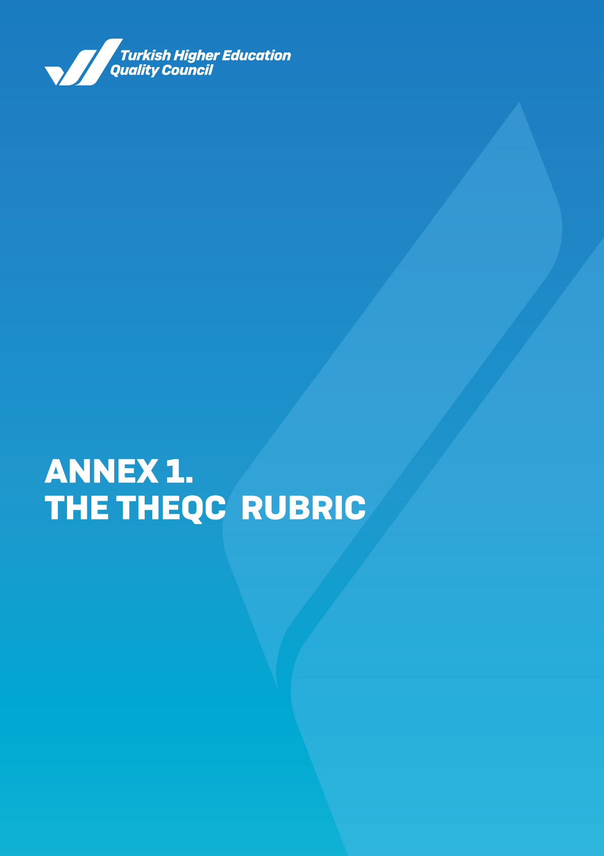

A. LEADERSHIP, GOVERNANCE AND QUALITY
A.1. Leadership and Quality
The institution should have a governance model to enable institutional transformation, utilise leadership approaches, create internal quality assurance mechanisms and internalize the quality assurance culture.
 | 1 | 2 | 3 | 4 | 5
A.1.1. Governance model and administrative structure  The governance model and administrative structure (institutional approach within the legal framework, traditions, preferences); decision-making mechanisms, control and balance factors, independent operation ability of the boards, representation of stakeholders, comparison of the foreseen governance model and its realization, the institutionality and continuity of the model are established and adopted. The actions, authority and responsibilities, and communication with the institution's academic community of board of trustees in foundation higher education institutions, and vice-rectors and consultants in public higher education institutions (senior governing body), the alignment of the governance style of the senior governing body with the targeted institutional identity is established and adopted. There is an organizational chart and affiliation/reporting relationships, job descriptions, and workflow processes reflecting the institution's current state. These documents are published, and it is ensured that the stakeholders recognize them. | The institution does not have a governance model and organizational structure that align with its mission and support the achievement of the strategic objectives. | The governance model and administrative structure, which ensure the achievement of the mission and strategic objectives of the institution and that align with its processes, are determined. | The governance model and organizational structure of the institution function in a manner that includes the entirety of units and areas. | The practices related to the governance and organizational structure of the institution are monitored and improved. | There are internalized, systematic and sustainable practices that can be used as examples of best practices.
Sample Evidence
- The governance model and organizational chart
- Practices/evidence showing that the institution implements its policy and strategic objectives regarding the governance and administrative areas
- Evidence showing follow-up and improvement regarding the governance and organizational structure practices
- Evidence for the specific approaches and practices developed by the institution in line with the institutional needs along with standard practices and legislation

A. LEADERSHIP, GOVERNANCE AND QUALITY
A.1. Leadership and Quality

 | 1 | 2 | 3 | 4 | 5
A.1.2. Leadership  The rector and process leaders in the institution have high ownership and motivation to create a quality assurance system and culture that takes into account the change, uncertainty and complexity in the higher education ecosystem. These processes are managed with an agile leadership approach.  An understanding of leadership and a coordination culture is established in units. In addition to their strategies in line with the values and goals of the institution, leaders also manage authority sharing, relations, time, institutional motivation and stress in an effective and balanced manner.  There is an efficient communication network between the academic and administrative units and the governing body.  Leadership processes and internalization of the quality assurance culture are evaluated continuously. | There is no effective leadership approach that supports the management of the quality assurance system and the internalization of the quality culture in the institution. | Leaders in the organization have ownership and motivation to manage the quality assurance system and internalize its culture. | The institution has leadership practices that complement the development of quality assurance system and culture throughout the entire institution. | Leadership practices and their contribution to the development of quality assurance system and culture are monitored, and relevant improvements are made. | There are internalized, systematic and sustainable practices that can be used as examples of best practices.
Sample Evidence
- Methods employed to evaluate and follow up the leadership qualifications and competencies of the institution’s administrators, results of the follow-up processes and related improvements
- Methods employed to evaluate and follow up the development of the quality culture in the institution, follow-up results and related improvements
- Evidence for the specific approaches and practices developed by the institution in line with the institutional needs along with standard practices and legislation

A. LEADERSHIP, GOVERNANCE AND QUALITY
A.1. Leadership and Quality

 | 1 | 2 | 3 | 4 | 5
A.1.3. Institutional transformation capacity  The institution has an agile governance competence that makes it ready for the future by considering the changes in the higher education ecosystem, global tendencies, national objectives, and stakeholders' expectations. It uses approaches such as change management, benchmarking, and innovation management to transform the institution in line with the objectives, mission and goals for compliance with the future and strengthens institutional authenticity. | The institution does not have change management. | The need for change has been determined in the institution. | The change management approach is expanded throughout the institution and being carried out holistically. | Change management practices that are implemented in accordance with objectives, mission and targets are monitored and measures are taken. | There are internalized, systematic and sustainable practices that can be used as examples of best practices.
Sample Evidence
- Change management model
- Change plans, roadmaps
- Analysis reports for change in the higher education ecosystem regarding its primary functions
- Future scenarios
- Benchmarking reports
- Innovation management system
- Change teams' documents
- Evidence for the specific approaches and practices developed by the institution in line with the institutional needs along with standard practices and legislation

A. LEADERSHIP, GOVERNANCE AND QUALITY
A.1. Leadership and Quality

 | 1 | 2 | 3 | 4 | 5
A.1.4. Internal quality assurance mechanisms  The actions, processes and mechanisms are planned and flow charts are devised based on the calendar year regarding the PDCA cycles. Responsibilities and authorities are defined. Completed practices are evaluated.  Other quality cycles, which are not designed on a calendar year basis, are indicated with evidence including all layers, and the completed practices are evaluated.  The institution has an accessible and updated document, such as a quality assurance guide that contains the details of its policy.  The processes and practices of the Quality Commission in the institution are defined and recognized by the employees. The commission takes active part in the establishment and development of the internal quality assurance system and assists in the program accreditation processes. The commission evaluates the results of the performed activities. This has an effect on decision-making mechanisms. | The institution does not have a defined internal quality assurance system. | The institution has defined internal quality assurance processes and mechanisms. | A transparent and holistic internal quality assurance system is implemented throughout the entire institution. | The internal quality assurance system mechanisms are monitored and improved with the relevant stakeholders. | There are internalized, systematic and sustainable practices that can be used as examples of best practices.
Sample Evidence
- Defined process documents like a quality assurance guide, the working procedures and principles of the Quality Commission
- Evidence demonstrating workflow charts, calendars, duties and responsibilities, and roles of the stakeholders
- Information Management System
- Institutional Risk Management Plan
- Feedback methods
- Documents related to stakeholder involvement
- Annual follow-up and improvement reports
- Evidence for the specific approaches and practices developed by the institution in line with the institutional needs along with standard practices and legislation

A. LEADERSHIP, GOVERNANCE AND QUALITY
A.1. Leadership and Quality

 | 1 | 2 | 3 | 4 | 5
A.1.5. Public disclosure and accountability  Public disclosure is adopted as a principle, the ways and how to use them are designed and announced in an accessible manner, and all steps about public disclosure are taken systematically. The website of the institution provides accurate, up-to-date, relevant and easily accessible information; a mechanism to ensure it is available. There are findings that the concepts of institutional autonomy and accountability complement each other. Internal and external accountability methods are designed and implemented. It is systematic, carried out within the framework of the announced calendar, and those in charge are clearly defined. Its effectiveness is evaluated with the received feedback. The relations of the institution with external stakeholders, associated local administrations, other universities, public institutions, non-governmental organizations, industrial organizations and local people in its region are evaluated. | There are no mechanisms in the institution to inform the public and establish accountability. | The institution has defined processes to inform the public in line with the principles of transparency and accountability. | The institution operates public disclosure and accountability mechanisms in line with its defined processes. | Public disclosure and accountability mechanisms of the institution are monitored and improved based on stakeholder views. | There are internalized, systematic and sustainable practices that can be used as examples of best practices.
Sample Evidence
- The principles, rules and methods adopted in relation to public disclosure and accountability and the evidence showing that information-sharing steps are announced
- Evidence showing that the web pages of the institution/units are up-to-date and accessible
- Evidence showing that internal and external defined processes for accountability are being implemented
- Satisfaction and feedback of internal and external stakeholders regarding public disclosure and accountability
- Evidence showing follow-up and improvement of public disclosure and accountability mechanisms
- Evidence for the specific approaches and practices developed by the institution in line with the institutional needs along with standard practices and legislation

A. LEADERSHIP, GOVERNANCE AND QUALITY
A.2. Mission and Strategic Goals
The institution should plan and implement its strategic goals and objectives created in accordance with its policies to achieve its vision, mission and objective, monitor and evaluate its results in scope of performance management, and ensure public disclosure.
 | 1 | 2 | 3 | 4 | 5
A.2.1. Mission, vision and policies  Mission and vision statements are defined, recognized and shared by employees of the institution. They are specific to the institution and provide guidance in creating a sustainable future.  There is a quality assurance policy which has been developed, taking stakeholders' views into account. The policy is recognized and shared by the employees of the institution. The policy document is simple, concrete and realistic. It outlines the sustainable quality assurance system. The governance, structure, primary mechanisms, the relationship between units within the institution, and access to units are explained.  Similarly, there are learning and teaching (including distance education), research and development, service to society, governance system, and internationalization policies that bear the same characteristics as the quality assurance policy. These policy statements have tangible results, and effects on the implementation of activities, and examples of these can be presented. | There is no defined mission, vision and policies in the institution. | There are defined and authentic mission, vision and policies in the institution. | There are practices in compliance with mission, vision and policies throughout the institution. | The practices based on the mission, vision and policies are followed up and evaluated with stakeholders in order to take necessary precautions. | There are internalized, systematic and sustainable practices that can be used as examples of best practices.
Sample Evidence
- Mission and vision
- Policy documents (the learning and teaching policy document should also include distance education)
- Documents showing that the policy documents were developed with the involvement of related stakeholders
- Expressions and practice examples that demonstrate a holistic relationship in the policy documents (mention of research in educational programs, mention of service to society in research processes, and mention of distance education)
- Evidence for the follow-up and evaluation of the policies
- Evidence for the specific approaches and practices developed by the institution in line with the institutional needs along with standard practices and legislation

A. LEADERSHIP, GOVERNANCE AND QUALITY
A.2. Mission and Strategic Goals

 | 1 | 2 | 3 | 4 | 5
A.2.2. Strategic goals and objectives  There is a mutual understanding and settled way of approaching the Strategic Plan*; short/medium and long-term goals, objectives, sub-objectives, actions, timing and prioritizing, people in charge, and financial resources available for the current period, all of which are created, taking the stakeholders' opinion (particularly strategic stakeholders) into account. While preparing the current strategic plan, the previous plan has been evaluated and used, the annual progress has been monitored, discussed in relevant boards, and necessary actions are taken.  * It is the document that defines the strategic goals and objectives and performance indicators for the foundation higher education institutions. | The institution does not have a strategic plan. | The institution has a declared strategic plan. | The institution has a holistic strategic plan adopted by all its units and recognized by its stakeholders, and practices agree with this plan. | The institution monitors the implementation of its strategic plan and evaluates it with the related stakeholders; the output is reflected in the institution's future plans. | There are internalized, systematic and sustainable practices that can be used as examples of best practices.
Sample Evidence
- A document disclosed to the public containing the strategic goals and objectives of the institution (strategic plan, strategy document, etc.) and the process of developing the document
- Evidence showing the involvement of internal and external stakeholders in the planning, doing, checking and acting stages of the institution's strategic plan
- Evidence for the alignment of the strategic plan and objectives with the United Nations Sustainable Development Goals
- Performance reports containing annual realisation monitoring of the indicators included in the Strategic Plan and improvement suggestions
- Improvement reports that analyse the results of practices, including requests, complaints, etc. from stakeholders within the scope of strategic goals and objectives
- Evidence for the specific approaches and practices developed by the institution in line with the institutional needs along with standard practices and legislation

A. LEADERSHIP, GOVERNANCE AND QUALITY
A.2. Mission and Strategic Goals

 | 1 | 2 | 3 | 4 | 5
A.2.3. Performance management  Performance management mechanisms in the institution are administered with a holistic approach. They assist the institution in its continuous improvement and prepare it for the future based on the strategic goals of the institution. The accuracy and reliability of the performance management are ensured with support from information and technology systems. The performance management that reflects the strategic perspective of the institution is maintained with a focus on process and stakeholder involvement.  Performance indicators that encompass all main institutional activities (general, key, distance education etc.) are defined and shared.  How the performance indicators are related to the internal quality assurance system is defined and recorded. There are examples of how this is reflected in decisions.  The changes over the years are monitored, the results of the follow-up are recorded, and there is proof that they are used as required. | The institution does not have performance management. | Performance indicators and performance management mechanisms are defined in the institution. | There are performance management practices throughout the entire institution. | The institution monitors performance indicators and performance management mechanisms' efficiency and makes improvements based on the follow-up process results. | There are internalized, systematic and sustainable practices that can be used as examples of best practices.
Sample Evidence
- Documentation of performance management procedures
- Performance indicators and key performance indicators
- Evidence of how the performance management process works
- Performance program report
- Evidence for the follow-up and improvement of process management mechanisms
- Evidence for the specific approaches and practices developed by the institution in line with the institutional needs along with standard practices and legislation

A. LEADERSHIP, GOVERNANCE AND QUALITY
A.3. Governance Systems
The institution should have a system to manage financial, human and information resources and processes to ensure the achievement of its strategic objectives in qualitative and quantitative manners.
 | 1 | 2 | 3 | 4 | 5
A.3.1. Information management system  Data on important activities and processes of the institution are collected, analysed, reported and used for strategic management. The Information Management System used by academic and administrative departments is integrated and feeds the quality management processes. The security, confidentiality and reliability of the Information Management System are provided. | The institution does not have an information management system. | The institution has information management systems to support the acquisition, storage, usage, processing and evaluation of institutional information. | The institution maintains an integrated information management system that supports the primary processes (learning and teaching, research and development, service to society, quality assurance). | The institution monitors and improves the integrated information management system. | There are internalized, systematic and sustainable practices that can be used as examples of best practices.
Sample Evidence
- Information Management System and the evidence of its functions
- Processes and practices for processing personal data
- Evidence for the follow-up and improvement of the Information Management System
- Processes and practices ensuring information security and reliability
- Risk, penetration tests and related improvements for cyber threats
- Evidence for the specific approaches and practices developed by the institution in line with the institutional needs along with standard practices and legislation

A. LEADERSHIP, GOVERNANCE AND QUALITY
A.3. Governance Systems

 | 1 | 2 | 3 | 4 | 5
A.3.2. Human resources management  The institution has rules and processes for the management of human resources. These processes are carried out transparently and recognized by everyone in the institution. Education and merit are the priority criteria, and the primary goal is to improve competencies.  Methods and mechanisms developed to identify and monitor employee (academic and administrative) satisfaction, complaints and suggestions are implemented, and the results are evaluated and improved. | The institution does not have a defined process for the management of human resources. | There are defined processes regarding human resources management in accordance with the strategic objectives of the institution. | The human resources management practices are maintained in line with the defined processes throughout the entire institution. | The institution monitors its human resources management practices and makes improvements with input from relevant internal stakeholders. | There are internalized, systematic and sustainable practices that can be used as examples of best practices.
Sample Evidence
- The human resources policy and objectives, and practices related to them (competencies, recruitment, in-service training, incentives and rewards, etc.)
- Employee (academic and administrative) satisfaction surveys, implementation systematics, and survey results
- Evidence showing follow-up and improvement of the human resources management practices
- Evidence for the specific approaches and practices developed by the institution in line with the institutional needs along with standard practices and legislation

A. LEADERSHIP, GOVERNANCE AND QUALITY
A.3. Governance Systems

 | 1 | 2 |  | 3 |  | 4 | 5
A.3.3. Financial management  Primary income and expense items are defined and monitored over years.  The Total Current Budget (income) = State education contribution (all income that comes directly from the central budget and does not include the research and development category) + student income (all income that is obtained from students: Formal and evening education, non-thesis master's degree, summer school, services/fees, dining and accommodation fees, etc.) + research income (acquired from the central budget of the state + national allocation - non-competitive projects) + national competitor research funding + international research funding [private account, circulating capital, acquisition from the foundation, and other accounted amounts] + service to society income (medicine, dentistry, etc.) health service income of faculties [circulating capital or other accounted amounts] + engineering, architecture, etc. faculty income for knowledge and technology transfer/projects/practices [circulating capital or other accounted amounts] + adult education/lifelong learning income + rental income + laboratory/experiment/measurement, etc. income [private account, circulating capital, acquisition from the foundation, and other accounted amounts] + donations (non-state resources that are transferred to the university with or without conditions) are monitored in detail and associated with the institutional profile. | The institution does not have a defined process for the management of financial resources. |  | The institution has defined processes for the management of financial resources that are in alignment with its strategic objectives. |  | The financial resources management practices are maintained in line with the defined processes throughout the entire institution. | The institution monitors and improves its financial resources management processes. | There are internalized, systematic and sustainable practices that can be used as examples of best practices.
Sample Evidence
- Defined processes and practices related to the management of financial resources (Distribution and efficient use of resources, variety of resources)
- Document showing the alignment of the planning, use, and follow-up practices of financial resources to the strategic plan of the institution
- Evidence for the follow-up reports and analyses and the improvement of the financial resources management practices
- Evidence for the specific approaches and practices developed by the institution in line with the institutional needs along with standard practices and legislation

A. LEADERSHIP, GOVERNANCE AND QUALITY
A.3. Governance Systems

 | 1 | 2 | 3 | 4 | 5
A.3.4. Process management  All processes and sub-processes of activities (including distance education) are defined. The accountable parties for processes, workflow, management and ownership are documented and internalised by the institution. There is evidence of successful process management. A continuous process improvement cycle is established. | The institution does not have defined processes for learning and teaching, research and development, service to society and governance system practices. | The institution has defined processes and sub-processes for its practices regarding learning and teaching, research and development, service to society and governance system. | Defined processes are managed throughout the entire institution. | The institution follows up its process management mechanisms and makes improvements with input from relevant stakeholders. | There are internalized, systematic and sustainable practices that can be used as examples of best practices.
Sample Evidence
- Process management model and/or Process Management Handbook
- Process Guides and Training Documents for Process Responsibles
- Process management practices (including distance education)
- Evidence showing involvement of stakeholders
- Evidence for the follow-up and improvement of process management mechanisms
- Evidence for the specific approaches and practices developed by the institution in line with the institutional needs along with standard practices and legislation

A. LEADERSHIP, GOVERNANCE AND QUALITY
A.4. Stakeholder Involvement
The institution should establish and manage the necessary systems to receive and respond to the feedback of its internal and external stakeholders in order to ensure their involvement in strategic decisions and processes, and to use them in their decisions.
 | 1 | 2 | 3 | 4 | 5
A.4.1. Internal and external stakeholder involvement  The mechanisms of involvement of internal and external stakeholders in decision-making, governance, and improvement processes are defined.  The efficiency, institutionalism, and continuity of the involvement are examined. Practice samples in the internal quality assurance system are available, particularly regarding the efficiency and involvement of students and external stakeholders. Results are evaluated, and relevant improvements are made. | The institution's internal quality assurance system does not have mechanisms that enable stakeholder involvement. | The institution has plans to involve stakeholders in the PDCA layers regarding processes about quality assurance, learning and teaching, research and development, service to society, governance system, and internationalization. | There are mechanisms for the involvement of stakeholders in the PDCA layers of all processes throughout the entire institution. | The operation of stakeholder involvement mechanisms is monitored and relevant improvements are made. | There are internalized, systematic and sustainable practices that can be used as examples of best practices.
Sample Evidence
- A list of internal and external stakeholders and evidence showing prioritization of them based on institutional processes
- Data collection tools and methods employed in collecting stakeholder opinion (surveys, focus group meetings, workshops, the data management system etc.)
- Documents demonstrating that stakeholder involvement in decision-making processes is ensured
- Evidence for follow-up and improvement of the operation of stakeholder involvement mechanisms
- Evidence for the specific approaches and practices developed by the institution in line with the institutional needs along with standard practices and legislation

A. LEADERSHIP, GOVERNANCE AND QUALITY
A.4. Stakeholder Involvement

 | 1 | 2 | 3 | 4 | 5
A.4.2. Student Feedback  Student opinions (about courses, course instructors, the diploma program, the quality of services and general satisfaction level etc.) are collected systematically by various means, and the results are shared and utilized efficiently. It is ensured that the methods used are reliable and valid and that data are consistent and representative.  There are various channels for students' complaints and/or suggestions which are recognized by students, and the fair and efficient operation of these channels are monitored. | The institution does not have mechanisms to collect student feedback. | The institution has established principles and rules related to the collection of student feedback (about courses, lecturers, programs, student workload* etc.) within its teaching processes. . | Student feedback is collected (at the end of each semester or academic year) in all programs. | Practices about collecting student feedback are monitored in all programs and they are improved with student involvement. Feedback results are reflected in decision-making processes. | There are internalized, systematic and sustainable practices that can be used as examples of best practices.
Sample Evidence
- Principles and rules about collecting student feedback
- Evidence for the types, methods and diversity of the defined student feedback mechanisms (including distance/blended education)
- Practices regarding the improvements made within the scope of student feedback
- Examples showing the involvement of students in decision-making mechanisms
- Evidence for the follow-up and improvement of student feedback mechanisms
- Evidence for the specific approaches and practices developed by the institution in line with the institutional needs along with standard practices and legislation

*Should bear the key principles of the 2015 ECTS User Guide.

A. LEADERSHIP, GOVERNANCE AND QUALITY
A.4. Stakeholder Involvement

 | 1 | 2 | 3 | 4 | 5
A.4.3. Alumni relations management  Alumni employment information like job placement, graduate education, income rate, and employer/alumni satisfaction is systematically and comprehensively collected, evaluated and used in the institutional development strategies. | The institution does not have an alumni tracking system. | The institution has plans for an alumni tracking system in order to evaluate whether the programs have reached their goals and objectives or not. | There are alumni tracking system practices throughout the programs in the entire institution. | The alumni tracking system practices are monitored and improvements on the programs are made based on needs. | There are internalized, systematic and sustainable practices that can be used as examples of best practices.
Sample Evidence
- Features of the alumni tracking system
- Satisfaction level about the competencies of the alumni and the level of attainment of program goals and objectives
- Updating works on the programs as part of the alumni tracking system
- Alumni feedback
- Evidence concerning the specific approaches and practices developed by the institution in line with the institutional needs along with standard practices and legislation

A. LEADERSHIP, GOVERNANCE AND QUALITY
A.5. Internationalization
The institution should manage its processes, form the organizational structure and monitor and evaluate periodically its results in accordance with its internationalization strategy and objectives.
 | 1 | 2 | 3 | 4 | 5
A.5.1. Management of internationalization processes  The management and organizational structure of internationalization processes are institutionalized. They are aligned to the internationalization policy of the institution. The operation and efficiency of the governance and organizational structure are checked. | The institution does not have management and organizational structure for the internationalization processes. | The institution has plans regarding the management and organizational structure of the internationalization processes. | The institution has completed its organizational structure for the management of the internationalization processes, and functions in a transparent, inclusive, and participatory manner. | The governance and organizational structure of the internationalization processes are monitored and improved. | There are internalized, systematic and sustainable practices that can be used as examples of best practices.
Sample Evidence
- Governance and organizational structure of internationalization processes
- Evidence of practice on the management of internationalization processes
- Evidence for the follow-up and improvement of the governance and organizational structure
- Evidence for the specific approaches and practices developed by the institution in line with the institutional needs along with standard practices and legislation

A. LEADERSHIP, GOVERNANCE AND QUALITY
A.5. Internationalization

 | 1 | 2 | 3 | 4 | 5
A.5.2. Internationalization resources  Resources allocated to internationalization (financial, physical, human power) are determined, shared and institutionalized. These resources are monitored and assessed qualitatively and quantitatively. | The institution does not have sufficient resources to maintain its internationalization activities. | The institution has plans for creating physical, technical and financial resources that are suitable in quality and quantity to maintain its internationalization activities. | The internationalization resources of the institution are managed considering the balance between its units. | The distribution of internationalization resources in the institution is monitored and improved. | There are internalized, systematic and sustainable practices that can be used as examples of best practices.
Sample Evidence
- Evidence showing institutional planning to maintain its internationalization activities
- Documents on the management of the resources allocated for international activities (usage rates of budgets allocated to Erasmus and other international programs, documents on the management of budgets and resources allocated to EU projects and bilateral protocols etc.)
- Evidence showing follow-up and improvement of the distribution of internationalization resources
- Evidence for the specific approaches and practices developed by the institution in line with the institutional needs along with standard practices and legislation

A. LEADERSHIP, GOVERNANCE AND QUALITY
A.5. Internationalization
 | 1 | 2 | 3 | 4 | 5
A.5.3. Internationalization performance  The internationalization performance is monitored. The follow-up mechanisms and processes are established and sustainable, and there is evidence of the steps taken for improvement. | The institution does not have internationalization activities. | The institution has plans about practices that are in line with its internationalization policy. | There are internationalization activities established throughout the entire institution. | Internationalization activities in the institution are followed up and improved. | There are internalized, systematic and sustainable practices that can be used as examples of best practices.
Sample Evidence
- Performance indicators regarding the strategic plan and internationalization policy
- Internationalization activities (International meetings organised, programs attended, activities within the scope of protocols, etc.)
- Mechanisms established to monitor whether the internationalization goals are achieved or not
- Annual self-evaluation reports and improvement works on the internationalization processes
- Evidence for the specific approaches and practices developed by the institution in line with the institutional needs along with standard practices and legislation

B. LEARNING AND TEACHING
B.1. Program Design, Evaluation and Update
The institution should design its teaching programs in line with the National Qualifications Framework for Higher Education in Türkiye (NQF-HETR) and the teaching objectives and learning outcomes; they should be evaluated and updated periodically to make sure that needs of students and the society are met.
 | 1 | 2 | 3 | 4 | 5
B.1.1. Design and approval of programs  The objectives and learning outcomes (objectives) of the programs are defined, and their alignment with the NQF-HETR is stated and shared with the public. The mission and vision of the institution are taken into account while determining the program competencies. Course information packages are created taking the national core program (if available), the criteria (e.g. accreditation criteria, etc., if available) into account. . The expressions of objectives clearly state the foreseen cognitive, affective and psychomotor levels. The institution has plans about how to monitor the realization of program outcomes; particularly, the evaluation methods and processes of the shared (generic) outcomes of the institution are stated in detail. There are department-based principles and rules about the structuring of learning outcomes and necessary teaching processes. The program states with which activities (competence-course-teaching method matrices) the competencies may be acquired. The competencies to be acquired based on education modes (formal, blended, distance) are defined for different fields. Physical and technological facilities (access, social distance, etc.) are taken into account when designing the programs. | The institution does not have defined program design and approval processes. | The institution has defined processes related to the design and approval of programs including principles, methods, alignment with the NQF-HETR, and stakeholder involvement. | Programs that are designed and approved and are in alignment with the program objectives and learning outcomes, are implemented throughout the entire institution, in line with the defined processes. | The design and approval processes of the programs are systematically monitored and improved by evaluating them with relevant stakeholders. | There are internalized, systematic and sustainable practices that can be used as examples of best practices.
Sample Evidence
- Defined processes that are used for program design and approval (its compliance with the education policy, manuals, guides, procedures and principles, etc.)
- The management and organizational structure of the program design and approval processes (Commissions, process managers, process flow, etc.)
- Evidence showing the alignment of program objectives and learning outcomes with NQF-HETR (academic program samples, current course syllabus samples, etc.)
- Evidence for a variety of practices in department/field-specific programs in distance/blended program design (evidence for taking the different distance education demands of departments into account)
- Evidence for stakeholder involvement in program design processes
- Evidence for follow-up and improvement of the program design and approval processes
- Evidence for the specific approaches and practices developed by the institution in line with the institutional needs along with standard practices and legislation

B. LEARNING AND TEACHING
B.1. Program Design, Evaluation and Update

 | 1 | 2 | 3 | 4 | 5
B.1.2. Course distribution balance of the program  The principles, rules and methods about course distribution of the program are defined. Teaching staff's fields of expertise and workload are considered in the course distribution, and the course distribution between them is done in a participatory manner. The teaching program (curriculum) takes into account the balance between compulsory and elective courses, field-specific and non-field-specific courses, and allows for cultural competence and acquaintance with other disciplines. The number of courses and the weekly course load are organized in a manner that allows students to spend time in extracurricular activities. The alignment with the goals and the efficiency of the course information packages designed by these principles are monitored and relevant improvements are made. | Principles and methods related to course distribution are not defined. | There are defined processes for course distribution that include principles and methods about dimensions like the balance between courses about teaching staff's fields of expertise; the balance between the field of study/professional knowledge/general knowledge and compulsory and elective courses; gaining cultural competence, and familiarizing students with different disciplines. | There are practices throughout the institution in accordance with the defined processes regarding the course distribution balance. | The course distribution balance in the programs is monitored and improved. | There are internalized, systematic and sustainable practices that can be used as examples of best practices.
Sample Evidence
- Principles and methods related to course distribution and related evidence
- Evidence showing that the balance of course distribution is taken into account in the announced course information packages
- Decisions of the education commission, senate decisions, etc.
- Evidence for follow-up and improvement of the course distribution balance
- Evidence for the specific approaches and practices developed by the institution in line with the institutional needs along with standard practices and legislation

B. LEARNING AND TEACHING
B.1. Program Design, Evaluation and Update
 | 1 | 2 | 3 | 4 | 5
B.1.3. The alignment of course objectives with program outcomes  The learning objectives of the courses (including blended and distance education) are defined, and the program outcomes and course objectives are aligned and declared. The expressions of objectives clearly state the foreseen cognitive, affective and psychomotor levels.  There are plans about how to monitor the realization of the course learning objectives, particularly, the methods and processes of the evaluation of objectives not related to the area of study (general) are stated in detail. | Course objectives and program outcomes are not aligned. | There are defined processes that include principles, methods and classifications about the design of the course objectives and their alignment to the program outcomes. | Course objectives are aligned with the program outcomes throughout the entire program and the course information packages are shared. | The alignment of the course objectives with the program outcomes is monitored and improved. | There are internalized, systematic and sustainable practices that can be used as examples of best practices.
Sample Evidence
- Evidence of directives and planning that show how the institution will implement effective processes for evaluating course objectives and measuring the achievement of curriculum learning objectives and their alignment with program outcomes
- Matching of program outcomes with the course objectives
- Evidence for the compatibility of the courses taken outside the program (face-to-face or distance) with the program outcomes
- Evidence for follow-up and improvement regarding the alignment of the course objectives with the program outcomes
- Evidence for the specific approaches and practices developed by the institution in line with the institutional needs along with standard practices and legislation

B. LEARNING AND TEACHING
B.1. Program Design, Evaluation and Update

 | 1 | 2 | 3 | 4 | 5
B.1.4. Student workload-based course design  All ECTS credit points are published on the website and verified by following student workload. There are internship and applied learning opportunities, and these are utilized through sufficient student workload and credits. The quality of completed practices is checked. Variations that arise from distance education are taken into consideration in the student workload-based design. | Courses are not designed based on student workload. | There are defined processes* that include principles and methods that comprise dimensions like internship, professional practices, or mobility explaining how to calculate student workload. | Courses are designed, announced and implemented according to student workload. | Student workload in programs is monitored and course design is updated accordingly. | There are internalized, systematic and sustainable practices that can be used as examples of best practices.
Sample Evidence
- ECTS course information packages* (Including distance and blended programs)
- Evidence showing that student workload credits in professional practices, exchange programs, internships and projects are defined*
- Documents including defined processes about the transfer and recognition of workload-based credits
- Documents and mechanisms showing that student involvement is enabled while determining student workload in programs
- Diploma Supplement
- Evidence showing the ECTS credits for courses and the follow-up of ECTS calculation tables
- ECTS calculation tables and additional documents (e.g. surveys with faculty members and students)
- Evidence showing that workload-based credits are updated in accordance with feedback
- Evidence for the specific approaches and practices developed by the institution in line with the institutional needs along with standard practices and legislation
*Should bear the key principles of the 2015 ECTS User Guide.

B. LEARNING AND TEACHING
B.1. Program Design, Evaluation and Update
 | 1 | 2 | 3 | 4 | 5
B.1.5. Follow-up and updating of programs  The follow-up of program objectives and learning outcomes is performed as planned for each program and course (face-to-face, distance, blended, open). The operation and results of this process are evaluated with the stakeholders. The statistical indicators about learning and teaching (courses offered each year, student numbers, grades, results of feedback, course diversity, lab applications, the balance of undergraduate/postgraduate programs, dropout numbers and reasons, etc.) are monitored periodically and systematically and are discussed, evaluated and compared to continue the development for quality education. There is a plan, incentive and practice for program accreditation; the accreditation strategy of the institution is stated, and its implications are discussed. The benefits of accreditation and its contribution to the internal quality assurance system are evaluated. | The institution does not have any mechanisms for the follow-up and updating of program outcomes. | Periods, principles, rules and indicators of the follow-up and updating of program outcomes are established. | Mechanisms about the follow-up and updating of the program outcomes are implemented in all programs. | The program outcomes are monitored with these mechanisms and are updated by including the opinion of relevant stakeholders. | There are internalized, systematic and sustainable practices that can be used as examples of best practices.
Sample Evidence
- Periods (annual and at the end of the program), principles, rules, indicators, plans and practices about the follow-up and updating of the programs
- Examples of mechanisms the institution has established to update the programs in line with the institution’s mission, vision and objectives
- Annual self-evaluation reports of programs (evaluation with a focus on program outcomes)
- Systems monitoring whether the program outcomes are achieved (the Information Management System)
- Improvements made on the basis of yearly and duration-based self-evaluation of programs
- Practices ensuring that all stakeholders are informed on the latest improvements and changes
- Feedback on whether the program has reached its goals or not
- Evidence showing that a sustainable teaching model required to carry out programs in extraordinary situations, such as natural disasters etc., has been created
- Evidence for the specific approaches and practices developed by the institution in line with the institutional needs along with standard practices and legislation

B. LEARNING AND TEACHING
B.1. Program Design, Evaluation and Update

 | 1 | 2 | 3 | 4 | 5
B.1.6. Management of learning and teaching processes  The institution has an organizational structure (university learning and teaching commission, learning and teaching centres, etc.), information management system and expert human resources to manage the learning and teaching processes holistically. Learning and teaching processes are implemented under the coordination of the senior management and the duties and responsibilities in this respect are defined.  Principles, rules and the calendar regarding the design, implementation, evaluation and update activities of learning and teaching programs are specified throughout the entire institution.  The compatibility between learning objectives, the teaching program (curriculum), the modality of educational services (face-to-face, distance, blended, open), teaching methods and measurement and evaluation in programs, and the coordination of all these processes are monitored by senior management. | There is no system in the institution to manage the learning and teaching processes holistically. | There are systems, principles and rules in the institution to manage the learning and teaching processes holistically. | Learning and teaching processes are managed in accordance with the defined rules and principles throughout the entire institution. | Practices for learning and teaching management system are followed up and the results of follow-up are used for improvements. | There are internalized, systematic and sustainable practices that can be used as examples of best practices.
Sample Evidence
- Organizational structure and workflow charts regarding the management of learning and teaching processes
- Rules, principles and the calendar regarding the processes of learning and teaching and measurement and evaluation
- Information Management System
- Evidence showing follow-up and improvement regarding the management of learning and teaching processes
- Evaluation reports regarding the follow-up work, reports on analysis of feedback or documents containing analysis, and arrangements for improvements made based on these documents
- Evidence for the specific approaches and practices developed by the institution in line with the institutional needs along with standard practices and legislation

B. LEARNING AND TEACHING
B.2. Implementation of Programs (Student-Centred Learning, Teaching and Evaluation)
The institution should implement student-centred and competence-based teaching, measurement and evaluation methods to achieve the aimed qualified alumni competencies. The institution should set out explicit criteria for student admission, the recognition and certification of degrees, diplomas and other qualifications and consistently implement the pre-defined and announced rules.
 | 1 | 2 | 3 | 4 | 5
B.2.1. Teaching methods and techniques  The teaching method is focused on engaging and interactive learning. Student-centred, competence-based, process and performance-based, interdisciplinary, integral, case/practice-based approaches that prioritize learning are adopted in all educational modalities (face-to-face, distance, blended) and the nature of these modalities are taken into account. The focus is on deep learning, and the engagement, motivation and commitment of the students rather than the transfer of knowledge.  Formal education processes are enriched with technological opportunities and the approaches such as flipped learning, project-based learning, etc., including associate, bachelor's, and postgraduate students. The involvement of students in research processes is facilitated through the curriculum, methods and approaches. The implementation, follow-up, and preventive measures of all these practices are systematically evaluated. | The institution does not have student-centred approaches in its learning and teaching processes. | The institution has plans, rules and principles about the implementation of student-centred approaches for the learning and teaching processes. | Student-centred teaching techniques and methods are applied in line with defined processes in the entirety of the programs. | Student-centred practices are monitored and improved with the involvement of relevant internal stakeholders. | There are internalized, systematic and sustainable practices that can be used as examples of best practices.
Sample Evidence
- Presence of student-centred teaching approaches in the course information packages
- Principles and mechanisms related to teaching methods and material development for distance education
- Defined processes and practices about engaging and interactive teaching methods
- Practices related to the student-centred learning and teaching approach in the training of trainers program content
- Evidence for follow-up of processes and related improvement efforts
- Evidence for the specific approaches and practices developed by the institution in line with the institutional needs along with standard practices and legislation

B. LEARNING AND TEACHING
B.2. Implementation of Programs (Student-Centred Learning, Teaching and Evaluation)
 | 1 | 2 | 3 | 4 | 5
B.2.2. Measurement and evaluation  Student-centred measurement and evaluation are implemented based on competence and performance and the self-expression of students is facilitated as much as possible.  The continuity of measurement and evaluation is provided through methods like multiple exam possibilities and assignments, projects, and portfolios, some of which are process-based (formative). Exam methods aligned with and suitable to course objectives and education modalities (face-to-face, distance, blended) are planned and implemented. There are mechanisms for exam practices and exam security (face-to-face/online exams, exams for disadvantaged groups).  The time and rater reliability and validity of measurement and evaluation practices are established. The institution improves its measurement and evaluation approaches and opportunities based on the feedback of students and teaching staff. The announcement, implementation, control, alignment with objectives of these improvements and the measures taken are examined. | The programs do not have student-centred measurement and evaluation approaches. | There are principles, rules and plans about student-centred measurement and evaluation. | There are diversified student-centred measurement and evaluation practices throughout the entire programs. | Student-centred measurement and evaluation practices are monitored and improved with the involvement of relevant internal stakeholders. | There are internalized, systematic and sustainable practices that can be used as examples of best practices.
Sample Evidence
- Planning documents, organisational structures and job descriptions that include student-centred measurement and evaluation approaches
- Practice examples regarding the diversity of assessment and evaluation in programs
- Exam specimens (of different measurement tools included in the program) used in the face-to-face/distance/blended courses
- Course information package specimens demonstrating that the measurement and evaluation practices are related to the course objectives and program competencies, and that they are based on student workload*
- Mechanisms related to specific measurement modalities like exams for disadvantaged groups and online exams
- Exam security mechanisms
- Evidence showing that improvements are made based on the follow-up process and with the involvement of stakeholders
- Evidence for the specific approaches and practices developed by the institution in line with the institutional needs along with standard practices and legislation

*Should bear the key principles of the 2015 ECTS User Guide.

B. LEARNING AND TEACHING
B.2. Implementation of Programs (Student-Centred Learning, Teaching and Evaluation)

 | 1 | 2 | 3 | 4 | 5
B.2.3. Student admission and the recognition and crediting of prior learning*  The principles and rules for student admission (including the students admitted through ways other than those coming with central placement) are defined and announced. These principles and rules are consistent, and the practices are transparent. Document requests like diplomas, certificates and similar documents are tracked meticulously.  Prior learning (face-to-face, public, distance/blended education, knowledge and skills obtained through informal learning) is recognized and credited. There is mobility support parallel to the internationalization policy, practices encouraging and facilitating students as well as practices preventing credit loss during mobility. | The institution does not have defined processes for student admission and the recognition and crediting of prior learning. | The institution has principles, rules and related plans about student admission and the recognition and crediting of prior learning. | There are practices based on plans regarding student admission and the recognition and crediting of prior learning throughout the entire institution. | Student admission and the recognition and accrediting of prior learning processes are monitored and improved, and updates are declared. | There are internalized, systematic and sustainable practices that can be used as examples of best practices.
Sample Evidence
- Principles and rules regarding student admission and recognition and crediting of prior learning
- Documents showing that student workload-based credits are used in the recognition of prior learning
- Evidence showing the practices’ continuity and coherence with the defined processes
- Mechanisms to inform stakeholders
- Evidence for the specific approaches and practices developed by the institution in line with the institutional needs along with standard practices and legislation

*Should bear the key principles of the 2015 ECTS User Guide.

B. LEARNING AND TEACHING
B.2. Implementation of Programs (Student-Centred Learning, Teaching and Evaluation)

 | 1 | 2 | 3 | 4 | 5
B.2.4. The certification of qualifications and the diploma  Approval of qualifications, conditions for graduation, and graduation decision-making processes are defined in a clear, understandable, comprehensive, and consistent manner and are shared with the public. Certification and diploma procedures are carried out and monitored in line with this defined process and necessary precautions are taken. | The institution does not have defined processes for diploma approval and the certification of other qualifications. | The institution has comprehensive, consistent and announced principles, rules, and processes about diploma approval and the certification of other qualifications. | Practices regarding diploma approval and certification of other qualifications are adopted throughout the entire institution. | Practices are monitored and defined processes are improved. | There are internalized, systematic and sustainable practices that can be used as examples of best practices.
Sample Evidence
- Defined processes and current practices about following up the academic and career development of students, the diploma approval, and the certification of qualifications
- Criteria employed in student admissions other than centrally placed student groups, such as the entrance exam for international students (YOS) placements, transfers, and admissions in double major (DMP) or minor programs
- Documents showing that student workload-based credits are recognized in exchange programs without any requirement of extra work*
- Evidence for the specific approaches and practices developed by the institution in line with the institutional needs along with standard practices and legislation

*Should bear the key principles of the 2015 ECTS User Guide.

B. LEARNING AND TEACHING
B.3. Learning Resources and Academic Support Services
The institution should have the necessary resources, infrastructure and environment to implement its learning and teaching activities and achieve its aim of qualified alumni competencies and should ensure that the learning opportunities are sufficient and accessible for all students. The institution should provide assistance services for the academic development and career planning of students.
 | 1 | 2 | 3 | 4 | 5
B.3.1. The learning environment and resources  Classrooms, laboratories, libraries, studios, coursebooks, online books/documents/videos, etc. resources are suitable in quality and quantity, accessible and are recognized by and available for students. The utilization of the learning environment and resources are monitored and improved.  The institution has a learning management system that can fully fulfil learning and teaching needs, is user-friendly, ergonomic, and has synchronous, and asynchronous learning, enriched content development, and also measurement and evaluation, and in-service training opportunities.  The learning environment and resources foster student-student, student-teaching staff, student-material interaction. | The institution does not have sufficient resources to maintain its learning-teaching activities. | The institution has plans to create learning resources that are in suitable quality and quantity (classrooms, laboratories, studios, a learning management system, printed/e-resources, human resources, etc.) in order to maintain its learning and teaching activities. | The management of learning resources in the entire institution is performed by taking into consideration the field-specific conditions, accessibility, and the balance between units. | The usage and development of learning resources are monitored and improved. | There are internalized, systematic and sustainable practices that can be used as examples of best practices.
Sample Evidence
- Learning resources and their state of sufficiency, plans and practices about their improvement
- Student Handbook (explaining the learning environments and resources offered by the institution)
- Analysis of student access to library, laboratory, etc.
- Evidence for accessibility of learning resources (including distance education)
- Examples about the learning management system practices
- Student feedback tools about the learning resources provided to students (Surveys etc.)
- Evidence showing that the learning resources are continuously monitored and improved
- Evidence for the specific approaches and practices developed by the institution in line with the institutional needs along with standard practices and legislation

B. LEARNING AND TEACHING
B.3. Learning Resources and Academic Support Services
 | 1 | 2 | 3 | 4 | 5
B.3.2. Academic support services  There are advisor teaching staff members who follow the academic development of students, lead them, help them solve their academic problems, and support their career planning. The advising system is monitored and improved through methods such as the student portfolio. Students can access support from their advisors easily and there are various ways of communication available (face-to-face, online).  There are psychological counselling and career centre services, these are accessible (face-to-face and online) and students are informed about them. The sufficiency of the services is monitored. | There are no assistance services for the academic development and career planning of students in the institution. | The institution has defined principles and rules about the academic development and career planning processes of students. | Support services for the academic development and career planning of students are carried out in the institution within the scope of defined principles and rules. | Practices regarding the academic development and career planning of students are monitored and improved with the involvement of students in the institution. | There are internalized, systematic and sustainable practices that can be used as examples of best practices.
Sample Evidence
- Defined processes used for academic support services
- Mechanisms and defined processes employed in the academic and technical advising systems for students in distance education (if available)
- Mechanisms for students' access to advisors
- Psychological counselling or career centre organisational structure
- Plans and practices regarding guidance, psychological counselling and career services
- Career centre practices
- Evidence for student involvement
- Results obtained from student feedback tools (surveys etc.) about services provided to students and related follow-up evidence
- Evidence of updates and improvements to the process
- Evidence concerning the specific approaches and practices developed by the institution in line with the institutional needs along with standard practices and legislation

B. LEARNING AND TEACHING
B.3. Learning Resources and Academic Support Services
 | 1 | 2 | 3 | 4 | 5
B.3.3. Facilities and infrastructure  Facilities and the infrastructure (dining hall, dormitory, technology-equipped study areas, health, transportation, IT services, infrastructure of distance education) are suitable in quantity and quality, accessible and recognized and utilized by students. The utilization of facilities and the infrastructure is checked. | The institution does not have facilities and the infrastructure of sufficient quality and quantity | There are plans in the institution to establish and use facilities and the infrastructure (dining hall, dormitory, health, library, transportation, information and communication infrastructure, infrastructure of distance education, etc.) of sufficient quality and quantity. . | The facilities and the infrastructure are accessible throughout the entire institution and they are utilized based on equal opportunity. | The usage of facilities and the infrastructure is monitored and improved based on needs. | There are internalized, systematic and sustainable practices that can be used as examples of best practices.
Sample Evidence
- Principles and rules about usage of facilities and the infrastructure
- Practices related to accessibility and usage
- The state of improvement of facilities and the infrastructure in relation to institutional growth (e.g. the relationship between the increase in the number of units and the increase in physical spaces)
- The status of infrastructure, facilities, hardware and software; in case there are distance education programs and practices in the institution
- Evidence for the follow-up, diversification and improvement of the facilities and infrastructure services
- Evidence for the specific approaches and practices developed by the institution in line with the institutional needs along with standard practices and legislation

B. LEARNING AND TEACHING
B.3. Learning Resources and Academic Support Services

 | 1 | 2 | 3 | 4 | 5
B.3.4. Disadvantaged groups  Access to educational opportunities of the disadvantaged, vulnerable and under-represented groups (disabled, poor, minority, immigrant, etc.) is ensured by considering the principles of equality, equity, diversity and inclusion. The distance education infrastructure is established by considering the needs of these groups. There are accessible university practices on university campuses where needed. The access of these groups to learning opportunities is monitored and improved in line with the feedback. | The institution does not have plans for the access of disadvantaged groups to learning opportunities. | The institution has plans for the access of disadvantaged groups to learning opportunities in a quality and just manner. | Practices regarding the access of disadvantaged groups to learning opportunities are carried out. | Practices regarding the access of disadvantaged groups to learning opportunities are monitored and improved by collecting the opinions of disadvantaged groups. | There are internalized, systematic and sustainable practices that can be used as examples of best practices.
Sample Evidence
- Plans and practices related to services that will be provided to disadvantaged student groups (their representation in boards, accessible university practices, if available, practices in distance education processes, etc.)
- Documents proving that feedback received from disadvantaged groups is used in follow-up and improvement mechanisms
- Evidence showing the follow-up and improvement of accessible university practices
- Evidence for the specific approaches and practices developed by the institution in line with the institutional needs along with standard practices and legislation

B. LEARNING AND TEACHING
B.3. Learning Resources and Academic Support Services
 | 1 | 2 | 3 | 4 | 5
B.3.5. Social, cultural and sporting activities  There is support for sites, budget, and guidance to students' societies and their social, cultural, or sporting activities.  Furthermore, there is an established administrative organization that manages and runs the social, cultural, and sporting activities. The activities carried out are monitored and improved in line with the needs. | The institution does not have social, cultural and sporting activities of sufficient quality and quantity. | The institution has plans to create opportunities for social, cultural and sporting activities. | The social, cultural, and sporting activities are accessible throughout the entire institution and they are utilized based on equal opportunity. | The social, cultural and sporting activity mechanisms are monitored,  activities are diversified and improved based on needs and requests. | There are internalized, systematic and sustainable practices that can be used as examples of best practices.
Sample Evidence
- Evidence for the planning and practice of social, cultural, and sporting activities
- List of the annual sporting, cultural and social activities organized for the students (with information like the type and subject of activity, the number of participants, etc. )
- Evidence for the accessibility of activities and that equal opportunity is taken into consideration
- Evidence for diversification of activities and improvements upon stakeholder feedback
- Tools, follow-up reports, evidence for diversification and improvement regarding the follow-up of social, cultural, and sporting activities
- Evidence for the specific approaches and practices developed by the institution in line with the institutional needs along with standard practices and legislation

B. LEARNING AND TEACHING
B.4. Teaching Staff
The institution must be fair and transparent in all the processes pertaining to the recruitment, appointment, promotion and teaching assignments of the teaching staff. It should provide continuous development opportunities regarding the learning-teaching competencies of teaching staff to achieve the aim of qualified alumni competencies.
 | 1 | 2 | 3 | 4 | 5
B.4.1. Recruitment, promotion and appointment criteria  The recruitment, promotion, and appointment criteria and processes for teaching staff (including the international teaching staff) are defined and accessible to the public. The related processes and criteria take academic merit into account and ensure equal opportunity. There is evidence that the practice is compatible with the criteria. The course load and the balance of course distribution between teaching staff are shared transparently. Individuals are aware of what the institution expects from the teaching staff. Merit is considered in selecting those assigned to give lectures from outside the institution, and the evaluation of their performance at the end of the semester is transparent and effective. The institution complies with learning and teaching principles and culture. | Recruitment, promotion and appointment processes are not defined in the institution. | The institution has defined its criteria for the recruitment, appointment and promotion of teaching staff, but field-specific necessities have not been analysed in the planning stage. | The institution implements the recruitment, promotion, and appointment criteria which are defined for all fields (recruitment, promotion, appointment, course assignment of teaching staff, etc.); these are recognized by stakeholders and included in decision-making. etc). | The results of the recruitment, promotion and appointment practices are monitored, evaluated, and necessary action is taken accordingly. | There are internalized, systematic and sustainable practices that can be used as examples of best practices.
Sample Evidence
- Evidence showing that teaching staff recruitment, promotion and appointment criteria are defined and disclosed to the public
- Practices ensuring that academic staff is assigned in courses related to their fields of expertise
- Evidence of follow-up and improvement of recruitment, promotion and appointment criteria
- Evidence for the specific approaches and practices developed by the institution in line with the institutional needs along with standard practices and legislation

B. LEARNING AND TEACHING
B.4. Teaching Staff
 | 1 | 2 | 3 | 4 | 5
B.4.2. Teaching competencies and development  Teaching competency development processes are planned based on need analyses, widely executed, and their effectiveness is periodically monitored. The institution provides systematic trainer-training activities (courses, workshops, seminars, etc.) for the teaching staff in order to assist them in learning and implementing interactive and active teaching methods, and distance teaching processes; there is also a teaching-learning centre structure that undertakes/performs this task. The pedagogical and technological competencies of teaching staff are improved. The teaching competency development performance of the institution is evaluated. | The institution does not have any plans available to improve the teaching competence of its teaching staff. | The institution has plans regarding the development of competencies of teaching staff in areas like student-centred learning, distance learning, measurement and evaluation, material development and the quality assurance system. | There are practices aiming at developing the teaching competencies of teaching staff throughout the entire institution. | Findings obtained from practices aiming at developing the teaching competencies of teaching staff are monitored, evaluated together with teaching staff, and precautions are taken. | There are internalized, systematic and sustainable practices that can be used as examples of best practices.
Sample Evidence
- Evidence for plans (scope, methodology, attendance details, etc.) regarding practices for the training of trainers (including distance education practices)
- Evidence for the practices related to the learning and teaching centres
- Evidence of practices (scope, methodology, attendance details, etc.) for the training of trainers (including distance education practices)
- Apart from the training of trainers, practices aimed at improving the teaching competence of faculty members
- Documents showing defined processes to monitor the performance of teaching staff in learning and teaching
- Evidence for the participation of teaching staff in the follow-up and improvement of the processes
- Evidence for follow-up and improvement of the development of teaching competency processes
- Evidence for the specific approaches and practices developed by the institution in line with the institutional needs along with standard practices and legislation

B. LEARNING AND TEACHING
B.4. Teaching Staff
 | 1 | 2 | 3 | 4 | 5
B.4.3. Incentives and rewards for educational activities  The institution has processes about incentives and rewards such as "outstanding education award" to increase the creative/innovative education practices and competition among teaching staff. Creative educational activities are included in the recruitment and promotion criteria in order to prioritize teaching and learning. | The institution does not have any incentive or reward mechanism for its teaching staff. | The institution has plans for the development of competency-based, fair and transparent incentive and reward mechanisms. | Incentive and rewards practices are implemented throughout the entire institution. | Incentives and rewards practices are monitored and improved. | There are internalized, systematic and sustainable practices that can be used as examples of best practices.
Sample Evidence
- Evidence of incentive mechanisms/defined processes spread throughout the institution for appreciating, recognising and rewarding teaching staff's teaching performance in teaching and learning
- Examples of practices carried out in this field
- Evidence of incentives and rewards for educational activities of the teaching staff
- Evidence of follow-up and improvement in the activities for appreciating, recognising and rewarding teaching staff's teaching performance
- Evidence for the specific approaches and practices developed by the institution in line with the institutional needs along with standard practices and legislation

C.RESEARCH AND DEVELOPMENT
Artistic activities are also evaluated within this scope under the Research and Development heading in the higher education institutions which offer art education degrees.
C.1. Management of Research Processes and the Research Resources
The institution should manage its research activities in a way that is aligned with its academic priorities determined within the framework of its strategic plan as well as the local, regional and national development objectives, adds value, and can be transformed into a social benefit. The institution should provide the required physical infrastructure and financial resources for these activities and enable their effective use.
 | 1 | 2 | 3 | 4 | 5
C.1.1. Management of research processes  Approaches adopted about the management of research processes, how the motivation and guidance function is designed, how clearly and definitely the short- and long-term goals are defined, and the research management team and their job descriptions are established, and practices are developed in line with these institutional preferences. The efficiency and success of the management of scientific research and artistic processes are monitored and improved. | The institution does not have plans for the management and organizational structure of its research processes. | The institution has plans that take matters like guidance and motivation into account regarding the management and organizational structure of its research processes. | The management and organizational structure of the research processes are practised in line with the institutional preferences throughout the entire institution. | The institution monitors the results and takes precautions about the efficiency of its research processes' management and organizational structure. | There are internalized, systematic and sustainable practices that can be used as examples of best practices.
Sample Evidence
- Management of the research processes and its organizational structure
- The research governance model and practices
- Evidence showing that the efficiency of the research management and organizational structure is monitored and improved
- Evidence for the specific approaches and practices developed by the institution in line with the institutional needs along with standard practices and legislation

C.RESEARCH AND DEVELOPMENT
C.1. Management of Research Processes and the Research Resources
 | 1 | 2 | 3 | 4 | 5
C.1.2. Internal and external resources  The institution's physical, technical and financial research resources are in line with and sufficient for its mission, objectives and strategies. The variety and sufficiency of the resources are monitored and improved.  There are easily accessible core intra-university funds for novice researchers. Research potential is developed through projects, conference participation, travel, expert invitation funds, and personal funds; staff motivation is fostered through rewards and competitive promotion criteria. The yearly changes, the efficiency and sufficiency, areas for further improvement and the level of meeting expectations of intra-university resources are evaluated.  Access to resources outside the university that are compatible with the mission and objectives are supported. Support units and methods employed for this purpose are defined and recognized by researchers. | The institution does not have sufficient resources to maintain its research and development activities. | The institution has plans for creating physical, technical and financial resources that are suitable in quality and quantity to be able to maintain its research and development activities. | The institution manages its research and development resources by taking its research strategy and the balance between its units into account. | The institution monitors and improves the variety and sufficiency of its research resources. | There are internalized, systematic and sustainable practices that can be used as examples of best practices.
Sample Evidence
- The research and development budget and its distribution
- Strategic partnerships formed in the scope of research activities (public or private)
- Evidence showing that the research and development resources are managed in line with the research strategy
- Evidence for the follow-up of and improvements in the variety and sufficiency of the research resources
- Defined processes regarding internal resources and their utilization (the Scientific Research Project (SRP) Directive, the Internal Resource Usage Directive, etc.)
- Distribution of internal resources among the units
- Methods and units formed to support the use of external resources
- Evidence showing the distribution of external resources
- Changes in the external resources by years
- Evidence for the specific approaches and practices developed by the institution in line with the institutional needs along with standard practices and legislation

C. RESEARCH AND DEVELOPMENT
C.1. Management of Research Processes and the Research Resources
 | 1 | 2 | 3 | 4 | 5
C.1.3. Doctoral programs and postdoctoral opportunities  The application processes, registered students, and alumni numbers, as well as the development trends of doctorate programs, are monitored. There are postdoctoral opportunities in the institution, and the inbreeding policy of the institution is clear. | The institution does not have doctoral programs or postdoctoral opportunities. | The institution has plans for doctoral programs and postdoctoral opportunities that align with the institution's research policy, objectives, and strategies. | The institution carries out doctoral programs and postdoctoral opportunities that support and align with the institution's research policy, objectives, and strategies. | The institution monitors and improves the outputs of doctoral programs and postdoctoral opportunities regularly. | There are internalized, systematic and sustainable practices that can be used as examples of best practices.
Sample Evidence
- Evidence for doctoral programs and postdoctoral opportunities
- The numbers and distribution across units of the students/researchers who benefit from these programs and opportunities
- Evidence for the follow-up and improvement of the doctoral programs and postdoctoral opportunities
- Evidence for the specific approaches and practices developed by the institution in line with the institutional needs along with standard practices and legislation

C. RESEARCH AND DEVELOPMENT
C.2. Research Competence, Collaborations, and Supports
The institution should give opportunities (training, collaborations, supports, etc.) to teaching staff and researchers to maintain and improve their scientific research and artistic competence .
 | 1 | 2 | 3 | 4 | 5
C.2.1. Research competencies and their development  The rate of researchers with a doctoral degree, the distribution of institutions from which they earned the doctoral degrees, clustering/expertise accumulation, analyses of compatibility with research objectives, and alignment with objectives are examined. The institution carries out systematic activities like trainings, workshops, project markets, etc. to develop the research and development competencies of the academic staff . | The institution does not have mechanisms for developing research competencies of the teaching staff. | The institution has plans for developing the research competencies of its teaching staff. | There are practices for developing the research competencies of the teaching staff throughout the institution. | The practices for developing research competencies of the teaching staff are monitored, and the results are evaluated with the teaching staff to take precautions in the institution. | There are internalized, systematic and sustainable practices that can be used as examples of best practices.
Sample Evidence
- Plans and practices (supportive training, international opportunities, project collaboration works, etc.) aiming at developing the research competencies of the teaching staff
- Feedback from teaching staff
- Evidence for the follow-up and improvement of the research competencies of teaching staff
- Evidence for the specific approaches and practices developed by the institution in line with the institutional needs along with standard practices and legislation

C. RESEARCH AND DEVELOPMENT
C.2. Research Competence, Collaborations, and Supports
 | 1 | 2 | 3 | 4 | 5
C.2.2. National and international joint programs and joint research units  There are efficient mechanisms that encourage inter-institutional collaboration, interdisciplinary initiatives, and joint initiatives that create synergy. Multiple research activities like joint research or postgraduate programs, involvement in research networks, presence of joint research units, and national and international collaboration are defined, supported and monitored systematically to make improvements that are aligned with the objectives of the institution. | The institution does not have any mechanisms for establishing joint programs or joint research units on national and international levels. | The institution has plans and mechanisms for multiple research activities like national and international joint programs and joint research units, participation in research networks, and establishing collaborations. | National and international joint programs and joint research activities are carried out throughout the institution. | The institution monitors intra- and inter-institutional joint programs and joint research activities on national and international levels and makes improvements based on assessment with relevant stakeholders. | There are internalized, systematic and sustainable practices that can be used as examples of best practices.
Sample Evidence
- Mechanisms for establishing joint programs or joint research units on national and international levels
- Evidence of bilateral agreements and collaborations on joint programs and joint research activities
- Research networks to which the institution is a party, joint programs and research units of the institution, studies and projects produced from joint researches
- Stakeholder feedback
- Evidence for the follow-up and improvement of joint programs and joint research activities
- Evidence for the specific approaches and practices developed by the institution in line with the institutional needs along with standard practices and legislation

C. RESEARCH AND DEVELOPMENT
C.3. Research Performance
The institution should periodically measure and evaluate its research activities based on data and publish their results. The obtained data should be employed for the periodic review and continuous improvement of the institution's research and development performance.
 | 1 | 2 | 3 | 4 | 5
C.3.1. The follow-up and evaluation of research performance  The institutional research activities are annually monitored, evaluated, and compared against objectives, and the reasons for deviations are examined. The level of internal and external awareness about the focus points of the university, international visibility, analysis of claimed expertise areas, and compatibility with objectives are systematically analysed. Incentive and appreciation mechanisms based on performance are employed. Competition with competitors and benchmarking are monitored. The systematic and permanent practice of performance evaluation is ensured. | The institution does not have mechanisms for monitoring and evaluating research performance. | The institution has principles, rules and indicators for the follow-up and evaluation of its research performance. | Mechanisms established for follow-up and evaluation of the research performance are used throughout the institution. | The institution monitors its research performance and makes improvements with input from relevant stakeholders. | There are internalized, systematic and sustainable practices that can be used as examples of best practices.
Sample Evidence
- Defined processes to monitor the research performance
- Mechanisms established to monitor whether the research objectives have been achieved or not
- Stakeholder feedback
- Evidence for the follow-up and improvement of research performance
- Evidence for the specific approaches and practices developed by the institution in line with the institutional needs along with standard practices and legislation

C. RESEARCH AND DEVELOPMENT
C.3. Research Performance
 | 1 | 2 | 3 | 4 | 5
C.3.2. Performance evaluation for the teaching staff/researchers  Each teaching staff member is expected to share their research performance; there are defined processes that regulate this, and relevant stakeholders recognize these processes. Research performance is monitored and evaluated annually and used in line with institutional policies. Outcomes, group averages, and scattering are shared transparently. The systematic and permanent practice of performance evaluation is ensured. | The institution does not have mechanisms for monitoring and assessing the research performance of the teaching staff. | The institution has principles, rules and indicators for the follow-up and evaluation of research performance of its teaching staff. | Established mechanisms for follow-up and assessment of the research and development performance of teaching staff are used throughout the institution. | The research and development performance of the teaching staff is monitored, and improvements are made by assessing them with the teaching staff. | There are internalized, systematic and sustainable practices that can be used as examples of best practices.
Sample Evidence
- Defined and valid processes related to the follow-up of academic staff's research and development performance (Regulations, directives, process definitions, measurement tools, guide, manual, an appreciation-recognition system, incentive mechanisms, etc.)
- Analysis reports of the research performance of teaching staff
- Feedback from teaching staff
- Evidence for follow-up and improvement records on research and development performance
- Evidence for the specific approaches and practices developed by the institution in line with the institutional needs along with standard practices and legislation

D. SERVICE TO SOCIETY
D.1. Management of Service to Society Processes and the Service to Society Resources
The institution should manage its service to society activities in accordance with its strategic objectives and goals. The institution should provide the required physical infrastructure and financial resources for these activities and enable their effective use.
 | 1 | 2 | 3 | 4 | 5
D.1.1. Management of service to society processes  The service to society policy, the management of the service to society processes, and their organizational structure are institutionalized. The management and organizational structure of the service to society processes are in alignment with the service to society policy of the institution, and job descriptions are determined. The functioning of the structure is monitored, and relevant improvements are made. | The institution does not have plans for the management and organizational structure of its service to society processes. | The institution has plans for the management and organizational structure of its service to society processes. | The management and organizational structure of the service to society processes are practised in line with the institutional preferences throughout the institution. | The institution monitors the results and takes precautions about the efficiency of the management and organizational structure of its service to society processes. | There are internalized, systematic and sustainable practices that can be used as examples of best practices.
Sample Evidence
- Evidence for the management and organisational structure of service to society processes
- Evidence showing the service to society governance model
- Units conducting service to society activities and the example practices
- Evidence for the follow-up and improvement regarding the efficiency of management and organizational structure of service to society processes
- Evidence for the specific approaches and practices developed by the institution in line with the institutional needs along with standard practices and legislation

D. SERVICE TO SOCIETY
D.1. Management of Service to Society Processes and the Service to Society Resources

 | 1 | 2 | 3 | 4 | 5
D.1.2. Resources  Resources allocated to service to society activities (financial, physical, human power) are determined, shared, and institutionalized; they are monitored and assessed. | The institution does not have sufficient resources to maintain its service to society activities. | The institution has plans for creating physical, technical and financial resources that are suitable in quality and quantity to be able to maintain its service to society activities. | The institution manages its service to society resources by taking the service to society strategy and the balance between units into account. | The institution monitors and improves the variety and sufficiency of its service to society resources. | There are internalized, systematic and sustainable practices that can be used as examples of best practices.
Sample Evidence
- Evidence of research and application centres and other units that conduct service to society activities
- Evidence showing the budget allocated to service to society activities and its distribution over the years
- Evidence showing that the service to society resources are managed in line with the service to society strategy
- Evidence for the follow-up and improvements of the variety and sufficiency of the service to society resources
- Evidence for the specific approaches and practices developed by the institution in line with the institutional needs along with standard practices and legislation

D. SERVICE TO SOCIETY
D.2. Service to Society Performance
The institution should periodically monitor and continuously improve the activities it maintains in line with its service to society strategy and objectives.
 | 1 | 2 | 3 | 4 | 5
D.2.1. The follow-up and evaluation of service to society performance  The institution engages in service to society activities that align with the UN Sustainable Development Goals, can meet the needs of the society including the disadvantaged groups and the environment, and add value. Service to society activities such as institutional collaborations on national and international levels, appointments to various public institutions and organizations, as well as the training, service, research, advising, etc. conducted through the units of the institution are monitored. The follow-up mechanisms and processes are established and sustainable. There is evidence for steps taken for improvement. | The institution does not have any mechanisms for the follow-up and improvement of its social contribution performance. | The institution has principles, rules and indicators for the follow-up and evaluation of its service to society performance. | Mechanisms established for follow-up and evaluation of the service to society performance are used throughout the institution. | The institution monitors its service to society performance and makes improvements with input from relevant stakeholders. | There are internalized, systematic and sustainable practices that can be used as examples of best practices.
Sample Evidence
- Service to society activities in line with the objectives of the institution
- Evidence of defined processes in place to monitor and evaluate service to society performance
- Evidence of mechanisms established to monitor whether the service to society objectives are achieved or not
- Evidence/follow-up reports showing that service to society activities carried out in the institution are evaluated
- Evidence/reports showing that improvements have been made based on the follow-up of service to society activities
- Protocols and agreements signed with collaborating institutions
- Stakeholder feedback
- Evidence for the follow-up and improvement of service to society performance
- Evidence for the specific approaches and practices developed by the institution in line with the institutional needs along with standard practices and legislation

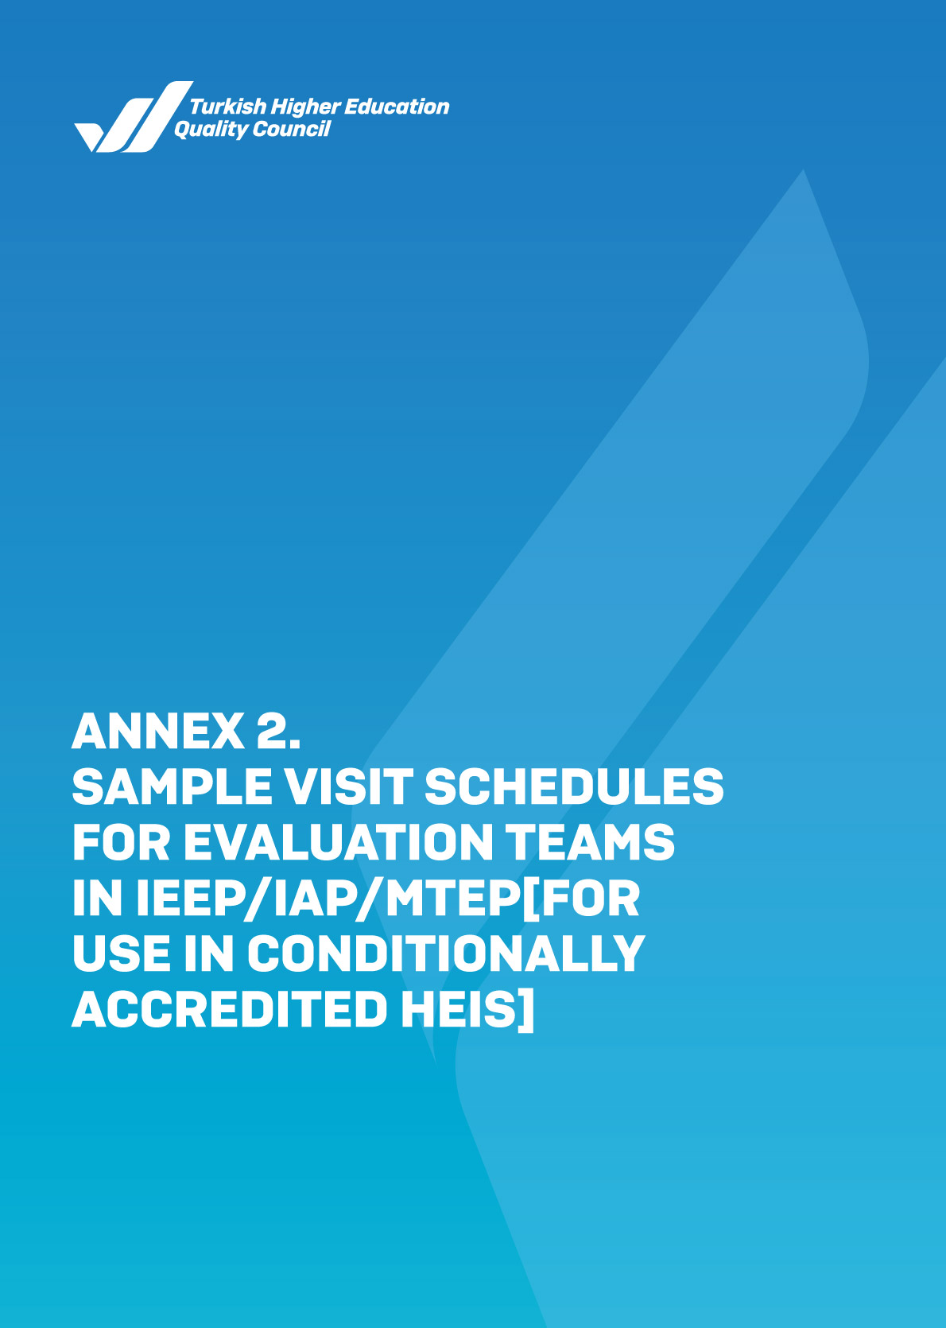

ANNEX-2/A SAMPLE PRE-VISIT PLAN FOR EVALUATION TEAMS - IEEP/IAP
Time | What to do with whom | Activities
Pre-Visit (Conducted generally 2-3 weeks before the site visit) (B.2.1)

10:00-12:30 | Meeting between the evaluation team members | Task distribution among team members, discussion on visit plan and the ISER(s) written by the institution, etc.
12:30-13:30 | Meeting between the evaluation team and the institution’s rector/director and senior management members | Self-introduction and exchange of views regarding the evaluation process
13:30-14:30 | Meeting between the evaluation team and the institution’s quality commission members | The Quality Commission gives general information about the functioning of the institution on quality assurance
14:30-16:00 | Meeting between the team leader and the rector/director | Design of the site visit schedule

NOTES:

Yellow highlights refer to the evaluation team’s activities in the institution,
Green highlights refer to the evaluation team’s own activities.
(Related sections of the THEQC International Institutional Accreditation Program Guide are indicated in parentheses).

ANNEX-2/B SAMPLE SITE VISIT PLAN FOR EVALUATION TEAMS - IEEP/IAP
Time | What to do with whom | Activities
Day 0 (Usually Sunday) (B.2.1)

Late morning  (11:30-12:00) | {The evaluation team’s transfer to the place of accommodation}
14:00-18:00 | Meeting between the evaluation team members | - Revision of the works in the scope of the pre-determined visit plan in cooperation with the institution by clearly expressing the timing and goal  - Ensuring consistency within the team regarding the evaluation of the institution by considering the THEQC Evaluation Criteria  - Reviewing the possible questions to be raised by the team members related to the site visit plan  - Sharing the contributions of the observers (if any) in the site visit activities with the evaluation team
19:00 | The team leader, team members, rector/director and other persons representing the institution come together (for an introduction meeting/dinner) in the evening. | - Meeting between team members, and the rector/director and team of the institution  - A general discussion and exchange of views on the site visit plan  - Negotiation of other aspects of the evaluation process.

Day 1 (Usually Monday) (B.2.2)
8:30 | {The evaluation team’s transfer to the institution}
9:00-09:30 | Meeting between the evaluation team and the rector/director | The quality assurance system of the institution and the institution’s general approaches in learning and teaching, research and development, service to society and governance processes are discussed. The matters that raise concerns or are not fully clarified in the ISER(s) are brought to the agenda by the team leader and clarified.
9:30-10:15 | Meeting between the evaluation team and the chairperson of the board of trustees (for foundation higher education institutions) | The institution’s quality assurance system and the distribution of duties in the institution’s governance processes are discussed.
10:15-11:15 | Meeting between the evaluation team and the institution’s quality commission members | The quality commission makes a presentation that provides up-to-date information on several topics, including the institution’s quality assurance system formed in line with the THEQC Evaluation Criteria, the role of the quality commission in the quality assurance system and decision-making processes, the institution’s strategic objectives and the role of these objectives in regional/national development goals, the institution’s governance approach in the processes related to learning and teaching, research activities, service to society and governance practices, the institution’s outlook on continuous improvement and the outcomes obtained in this scope, works for THEQC Evaluation Criteria, and other common aspects of all units of the institution. Following the presentation, a Q&A session is held.
11:15-12:45 | Meeting between the evaluation team and the members of the institution’s senate and executive board | Several key issues are addressed, including the institution’s quality assurance system formed in line with the THEQC Evaluation Criteria, the institution’s strategic objectives and the role of these objectives in regional/national development goals, the institution’s governance approach in the processes related to learning and teaching, research activities, service to society and administrative practices, the institution’s outlook on continuous improvement, and the outcomes obtained in this scope.
12:40-13:30 | Within the scope of the site visit, if it is necessary and appropriate for both parties (team/institution), the team may meet with the institution's officials at lunch to continue the discussions. | First impressions of the site visit (notes on the ISER, first meeting with the rector/director, the meeting held with the quality commission members and the campus visit) are shared.

13:30-14:15  (The evaluation team visits the faculties of the institution. When necessary, the team may split into groups comprising at least two evaluators and pay synchronous visits to different faculties depending on the institution's size.) | Two members of the evaluation team meet the dean and assistant dean(s) of Faculty A | Two members of the evaluation team meet the dean and assistant dean(s) of Faculty B | The team obtains information on the objectives of the faculty, the role of these objectives in the institution’s strategic goals, stakeholder involvement in related processes, quality processes in the faculty, learning outcomes of the faculty’s programs, R&D activities, and continuous improvement approach.
14:15-15:15 | Two members of the evaluation team meet the academic staff of Faculty A. | Two members of the evaluation team meet the academic staff of Faculty B. | The relations of the teaching staff with the senior management are examined, and opinions are taken about their roles in the quality assurance system, staff recruitment, and the policies related to the academic staff's self-development and motivation. (Deans and assistant deans should not attend this meeting. Only the academic staff should attend this meeting.)
15:15-16:15 | Two members of the evaluation team meet the students of Faculty A. | Two members of the evaluation team meet the students of Faculty B. | The students are asked to share their views on several subjects, including student involvement in decision-making processes, quality assurance system, educational services, and student support services.
16:30-18:00 | The evaluation team meets the stakeholders of the institution. |  | The opinions of the stakeholders about the university are taken.
18:15 | {The evaluation team’s transfer to the place of accommodation}
19:30-20:30 | Dinner |  | Team members
20:30 | The team members hold a meeting to share and review their first-day observations and make plans for the second day. |  | The impressions of the first day are shared, and the tasks of the second day are discussed.

Day 2 (Usually Tuesday) (B.2.3)

8:30 | {The evaluation team’s transfer to the institution}
9:00-9:45  The evaluation team visits academic units (schools, vocational schools, institutes, etc.) of the institution. When necessary, the team can split into groups comprising at least two persons and pay visits simultaneously to different units depending on the institution's size) . | Two members of the evaluation team meet the administrators of a School/Institute/Vocational School C. | Two members of the evaluation team meet the administrators of a School/Institute/Vocational School D. | The team obtains information on the dissemination of quality processes in the unit(s), the objectives of the unit(s), the role of these objectives in the institution’s strategic objectives, stakeholder involvement in related processes, learning outcomes of the programs within the units and continuous improvement works.
09:45-10:45 | Two members of the evaluation team meet the academic staff of School/Institute/Vocational School C. | Two members of the evaluation team meet the academic staff of School/Institute/Vocational School D. | The relations of the teaching staff with the senior management are examined, and opinions are taken about the quality assurance system's role in the staff's activities, the policies regarding recruitment, self-development, and the motivation of the academic staff. (Deans and associate deans should not attend this meeting). Only the academic staff should attend this meeting.)
10:45-11:45 | Two members of the evaluation team meet the students of School/Institute/Vocational School C. | Two members of the evaluation team meet the students of School/Institute/Vocational School D. | The students are asked to share their views on several subjects, including student involvement in decision-making processes, quality assurance system, educational services, and student support services.
12:30-13:30 | Lunch
14:00-15:00 | The evaluation team meets the managers of the administrative units (Department of Personnel, Department of Health, Culture and Sports, Registrar’s Office, Department of Library and Documentation, Career Centre, Office for Students with Disabilities, etc.). |  | The team meets the managers/directors of the administrative units and obtains information on the dissemination of quality processes in units, the objectives of the unit(s), the role of these objectives in the institution’s strategic goals, stakeholder involvement in related processes, and continuous improvement works.
15:00-16:00 | Meeting with the administrative staff of selected administrative units |  | Administrative staff’s relation to the managers/directors, the staff's role in the quality assurance system, the professional development and motivation of the staff, and intra-institutional communication are discussed.
16:00-17:30 | Meeting with the directors of research units (actively operating Research Centres, Technocity, Technology Transfer Offices, etc.) |  | The objectives of related units, the role of these objectives in the institution’s strategic goals, stakeholder involvement in processes, quality processes, and continuous improvement works are discussed.
17:30 | {The evaluation team’s transfer to the place of accommodation}
18:00-19:00 | Dinner
19:30 | Preparation of "Exit Notification" to be verbally communicated by the evaluation team at the exit meeting |  | The evaluation team gets together and prepares for the Exit Statement to be delivered verbally at the exit meeting.

Day 3 (Usually Wednesday) (B.2.4)

8:30 | {The evaluation team’s transfer to the institution}
09.00-09.45 | A brief meeting with the rector/director | Opinions are expressed on the site visit process and the aspects included in the "Exit Statement."
09:45-11:45 | Final Meeting | The evaluation team conducts a "Final Meeting" with the Rector/Director and the officials working at the institution, such as vice-rectors, deans, directors, quality commission members, other managers, etc. The team leader and members verbally present the exit statement. Following a brief Q&A session, the rector/director and the team leader end the meeting.
12:00 | The evaluation team leaves the institution
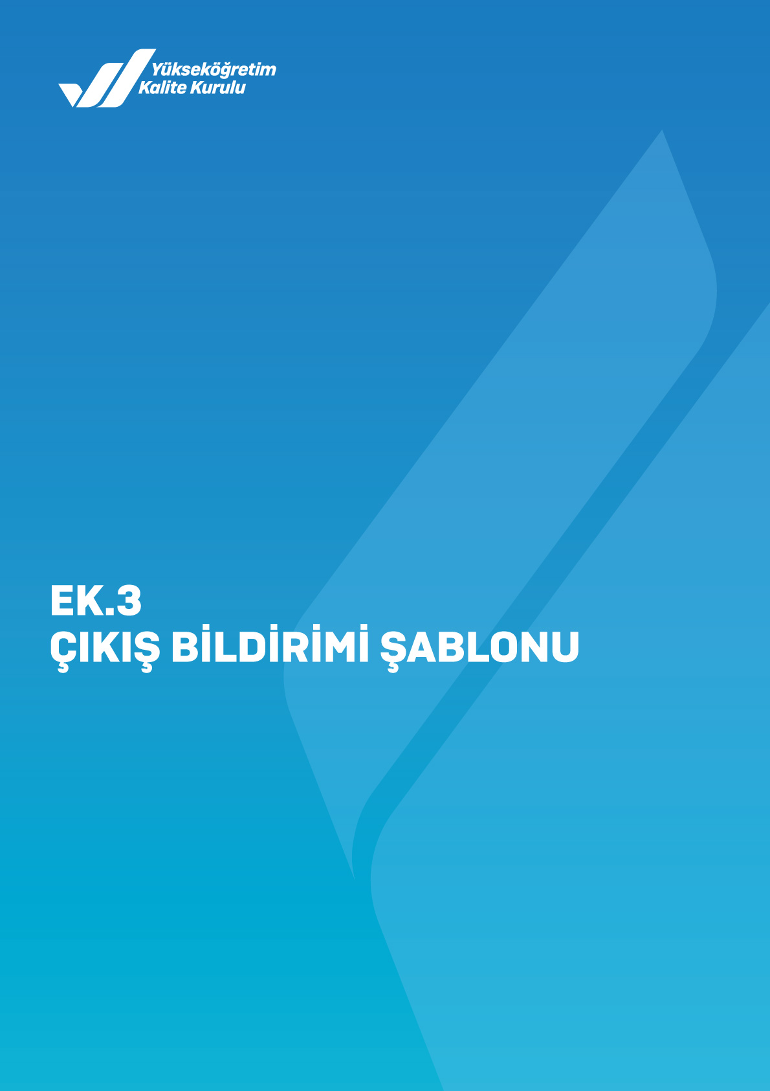
NOTES:
Yellow highlights refer to the evaluation team’s activities in the institution,
Green highlights refer to the evaluation team’s own activities.
Blue highlights refer to the lunch/dinner meetings in which the evaluation team meets the institution’s representatives, and
Purple highlights refer to the lunch/dinner meetings exclusive to the evaluation team.
(Related sections of the THEQC Evaluation Guide are indicated in parentheses), [Institution's members expected to attend meetings are indicated in square brackets], {Team members' transportation details are indicated in curly brackets}.
While completing the required information in the table, abbreviations below may be used. It is important to state the names of units and departments as they are used in the institution.
Abbreviations:< R: Rector; VR: Vice Rector(s); RA: Rector's Advisor(s); SG: Secretary General; QCM: Quality Commission Members; D: Dean; AD: Assistant Dean; HoD: Head of Department; DHoD: Deputy Head of Department; RO: Registrar's Office; HoSAD: Head of Student Affairs Department; HoITD: Head of Information Technologies Department; HoLDD: Head of Library and Documentation Department; HoSDD: Head of Strategy Development Department; Support Departments/Units: the related departments of Physics, Chemistry, Mathematics, Biology, Computer, Foreign Languages, Modern Languages, Turkish Language and Literature, History, and departments of Fine Arts and Literature faculties, etc.
*It is important to determine the names of the managers/directors, academic and administrative staff, students, and stakeholders who will attend the meetings in advance for the proper operation of the process.
*In focus group discussions, attention should be paid to building rapport, not having subordinate and superior relations between the participants, ensuring that the participants reflect the differences of the relevant focus group to provide more benefits to the institution, and inviting in only the pre-determined focus group members.
*In foundation vocational schools, the process is carried out by the evaluation team and the vocational school director.

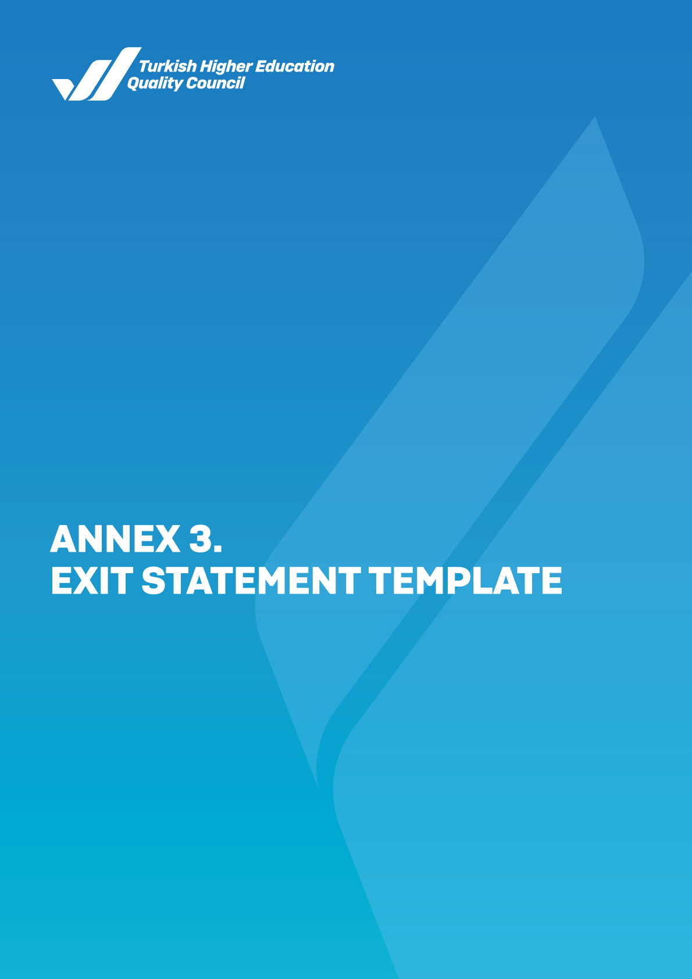
EXIT STATEMENT TEMPLATE

A Final Meeting is held with the participation of the rector/director of the higher education institution, other officials of the institution (vice-rectors, deans, directors, quality commission members, administrators, etc.), and the internal and external stakeholders to be invited before the evaluation team leaves at the end of the visit. The Exit Statement is prepared as the basis for the Institutional Feedback Report (IFR) / Institutional Accreditation Report (IAR) to be presented verbally. The Exit Statement includes the general evaluation of the institution within the scope of learning and teaching, research and development, service to society and governance processes based on the impressions of the evaluation team after the ISER evaluation, preliminary visit and site visit. In this context, the strengths and areas for improvement regarding the existing quality assurance system and how the quality assurance system is operated for each process, improvement suggestions and observations within this scope are shared one by one.

The Exit Statement should be a text on which all team members agree. It is recommended that the notes of the team leader and the evaluators are collected regularly every evening during the visit process to facilitate the writing phase of the Exit Statement. Due care should be taken to ensure that the issues specified in the Exit Statement contribute to the development and improvement of the institution and that the language used is clear and understandable. It should not be missed out that the statements to be included in this document will constitute the basis for the IFR/IAR, which will be written later. In this regard, expressions that will contradict or create an inconsistency with the IFR/IAR should not be included in the Exit Statement.

The goal, scope, general format, and framework of the evaluation process are briefly mentioned in the “Exit Statement". Then, the process steps to be followed regarding the IFR/IAR submission to the institution, the creation of the IFR/IAR's final version following the institution's response, and then the reconciliation with the institution at this stage are explained.

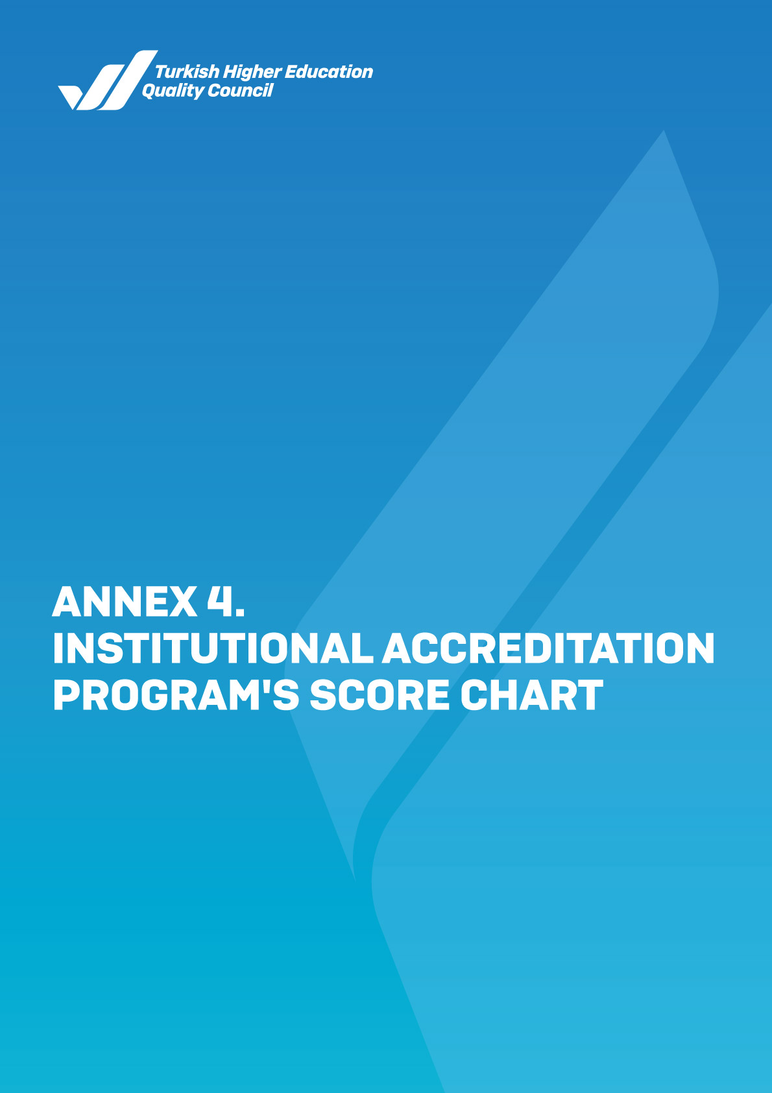
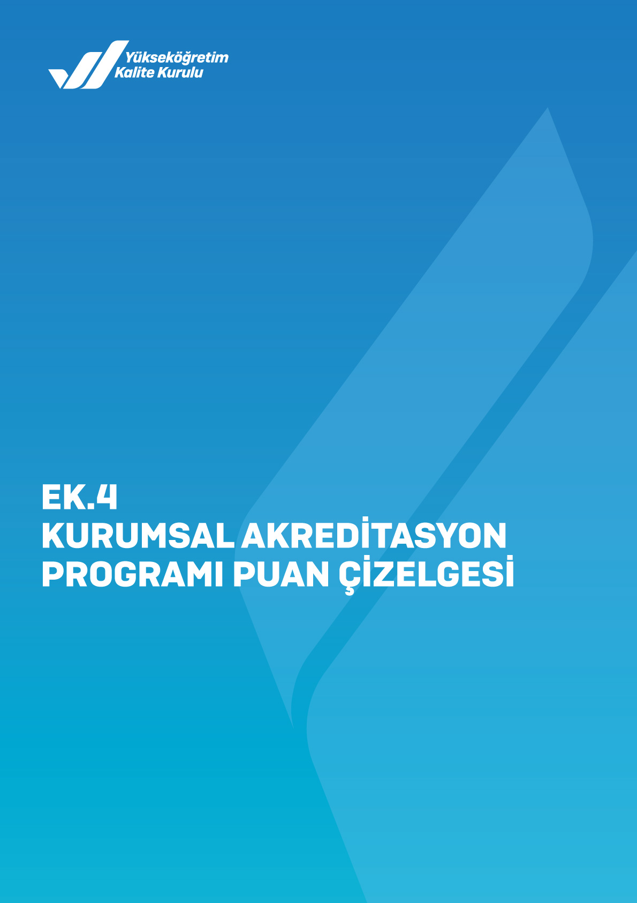
SCORING SYSTEM FOR THE RUBRIC

MAIN HEADING | CRITERIA | SCORE
A. LEADERSHIP, GOVERNANCE AND QUALITY  300 POINTS | A.1. Leadership and Quality | 60
A. LEADERSHIP, GOVERNANCE AND QUALITY  300 POINTS | A.2. Mission and Strategic Goals | 60
A. LEADERSHIP, GOVERNANCE AND QUALITY  300 POINTS | A.3. Governance systems | 60
A. LEADERSHIP, GOVERNANCE AND QUALITY  300 POINTS | A.4. Stakeholder Involvement | 60
A. LEADERSHIP, GOVERNANCE AND QUALITY  300 POINTS | A.5. Internationalization | 60
B. LEARNING AND TEACHING  400 POINTS | B.1. Program Design, Evaluation, and Update | 140
B. LEARNING AND TEACHING  400 POINTS | B.2. Implementation of Programs (Student-Centred Learning, Teaching and Evaluation) | 80
B. LEARNING AND TEACHING  400 POINTS | B.3. Learning Resources and Academic Support Services | 80
B. LEARNING AND TEACHING  400 POINTS | B.4. Teaching Staff | 100
C. RESEARCH AND DEVELOPMENT  200 POINTS | C.1. Management of Research Processes and the Research Resources | 50
C. RESEARCH AND DEVELOPMENT  200 POINTS | C.2. Research Competence, Collaborations, and Supports | 50
C. RESEARCH AND DEVELOPMENT  200 POINTS | C.3. Research Performance | 100
D. SERVICE TO SOCIETY  100 POINTS | D.1. Management of Service to Society Processes and the Service to Society Resources | 40
D. SERVICE TO SOCIETY  100 POINTS | D.2. Service to Society Performance | 60

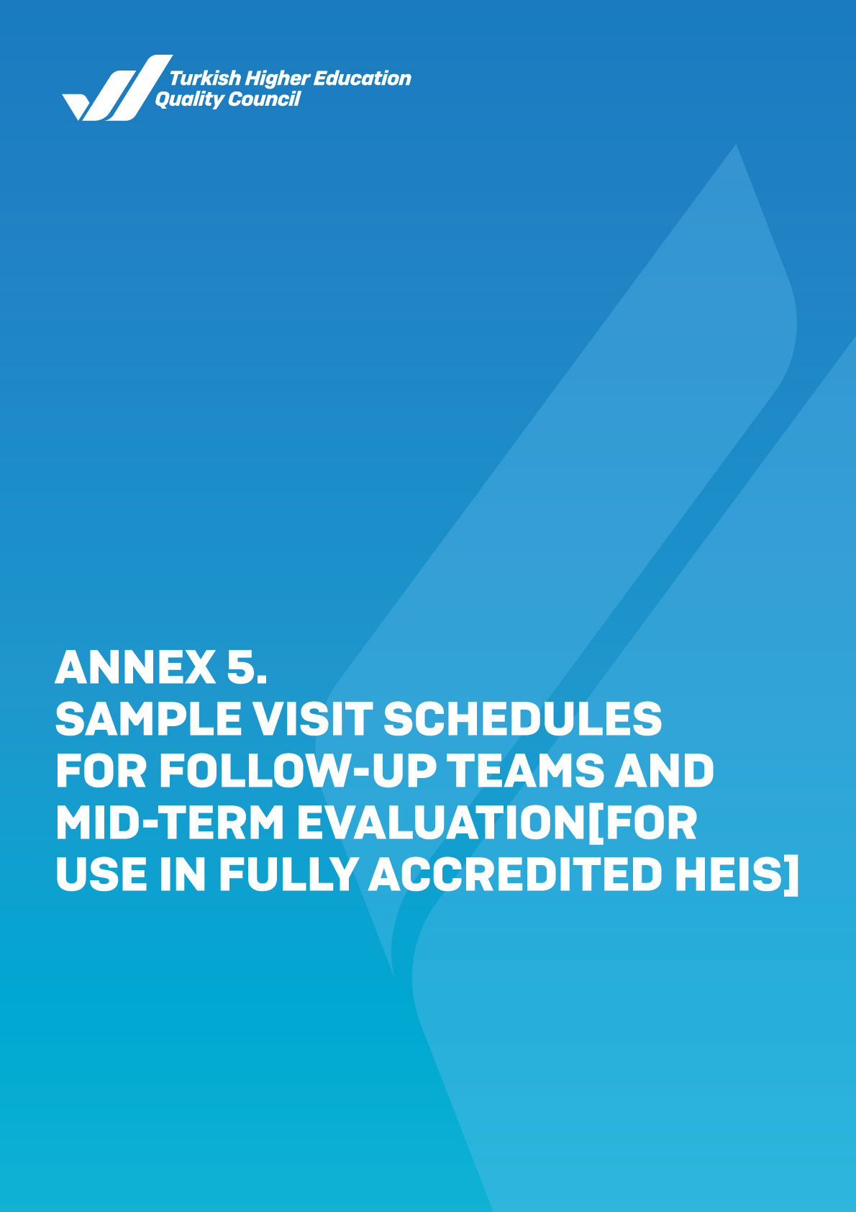
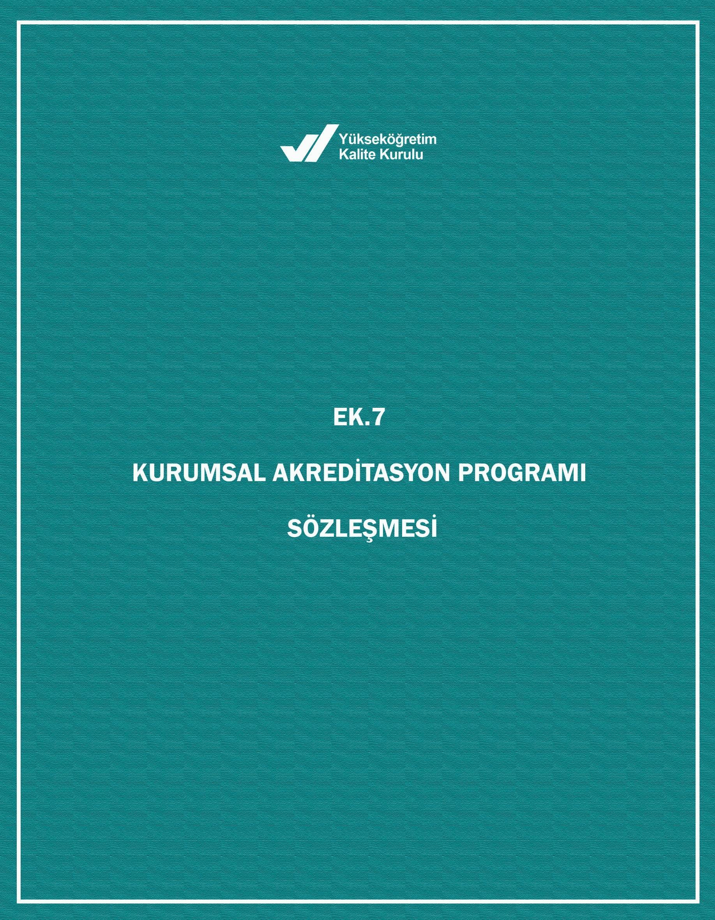
ANNEX-5/A SAMPLE VISIT SCHEDULE FOR FOLLOW-UP TEAMS
Time | What to do with whom | Activities
Day 1 (Usually Monday)

9:00-10:00 | The follow-up team meets among themselves
10:00-10:30 | Meeting between the follow-up team and the rector/director
10:30-10:45 | BREAK
10:45-11:15 | Meeting between the follow-up team and the chairperson of the board of trustees (for foundation higher education institutions) | The institution's task sharing in the administrative processes and institutional quality assurance system are discussed, and opinions about the follow-up process are shared.
11:15-12:15 | Meeting between the follow-up team and the institution’s quality commission members | The commission conveys up-to-date information about the work carried out by the institution, taking into account the existing ISER and IFR. Works on the subject of “areas for improvement” in the IFR are discussed. Following the meeting, a Q&A session is held.
12:15-13:30 | Lunch
13:30-15:00 | Informative presentation of the rector/director to the follow-up team and senate members about the improvements made within the scope of the IFR | Considering the existing ISER and IFR, the results obtained about the work carried out by the institution within the scope of "areas for improvement" are discussed.
15:00-15:15 | BREAK
15:15-16:00 | Meeting between the units and the follow-up team  *Only when necessary | The follow-up team may plan meetings with academic and/or administrative units, students or stakeholders, taking into account the "areas for improvement" in the IFR. These interview(s) may be held at a central location on the campus or at units, according to the follow-up team's plan. Within the scope of the interview(s), the results obtained from the works carried out in line with the "areas for improvement" in the IFR are discussed.
16:00-16:15 | BREAK
16:15-16:45 | Meeting between the follow-up team and the rector/director | Opinions are expressed on the visit process and the aspects to be included in the follow-up report.

NOTES:
While completing the required information in the table, abbreviations below may be used. It is important to state the names of units and departments as they are used in the institution.
Abbreviations:< R: Rector; VR: Vice Rector(s); RA: Rector's Advisor(s); SG: Secretary General; QCM: Quality Commission Members; D: Dean; AD: Assistant Dean; HoD: Head of Department; DHoD: Deputy Head of Department; RO: Registrar's Office; HoSAD: Head of Student Affairs Department; HoITD: Head of Information Technologies Department; HoLDD: Head of Library and Documentation Department; HoSDD: Head of Strategy Development Department; Support Departments/Units: the related departments of Physics, Chemistry, Mathematics, Biology, Computer, Foreign Languages, Modern Languages, Turkish Language and Literature, History, and departments of Fine Arts and Literature faculties, etc.

*It is important to determine the names of the administrators, academic and administrative staff, students, and stakeholders who will attend the meetings in advance for the proper functioning of the process.
*In focus group discussions, attention should be paid to building rapport, not having subordinate and superior relations between the participants, ensuring that the participants reflect the differences of the relevant focus group to provide more benefits to the institution, and inviting in only the pre-determined focus group members.

SAMPLE SITE VISIT SCHEDULE FOR MID-TERM EVALUATION TEAMS (FOR USE IN FULLY-ACCREDITED HEIs)*
Time | What to do with whom | Activities
Day 1 (Usually Monday)

9:00-10:00 | The mid-term evaluation team meets among themselves
10:00-10:30 | Meeting between the mid-term evaluation team and the rector/director
10:30-10:45 | BREAK
10:45-11:15 | Meeting between the mid-term evaluation team and the chairperson of the board of trustees (for foundation higher education institutions) | The institution's task sharing in the administrative processes and institutional quality assurance system are discussed, and opinions about the mid-term evaluation process are shared.
11:15-12:15 | Meeting between the mid-term evaluation team and the institution’s quality commission members | The commission conveys up-to-date information about the work carried out by the institution, taking into account the existing ISER and IAR. Works on the subject of “areas for improvement” in the IAR are discussed. Following the meeting, a Q&A session is held.
12:15-13:30 | Lunch
13:30-15:00 | Informative presentation of the rector/director to the mid-term evaluation team and senate/council members about the improvements made within the scope of the IAR | Considering the existing ISER and IAR, the results obtained about the work carried out by the institution within the scope of "areas for improvement" are discussed.
15:00-15:15 | BREAK
15:15-16:00 | Meeting between the units and the mid-term evaluation team  *Only when necessary | The mid-term evaluation team may plan meetings with academic and/or administrative units, students or stakeholders, taking into account the "areas for improvement" in the IAR. These interviews may take place at a central location on the campus or the relevant units if the mid-term evaluation site visit is conducted face-to-face. Within the scope of the interview(s), the results obtained from the works carried out in line with the "areas for improvement" in the IAR are discussed.
16:00-16:15 | BREAK
16:15-16:45 | Meeting between the mid-term evaluation team and the rector/director | Opinions are expressed on the visit process and the aspects to be included in the Mid-term Evaluation Report.
* This schedule was designed according to an online site visit, but if deemed necessary by THEQC, the site visit can also be conducted face-to-face following the same schedule.

NOTES:
While completing the required information in the table, abbreviations below may be used. It is important to state the names of units and departments as they are used in the institution.
Abbreviations:< R: Rector; VR: Vice Rector(s); RA: Rector's Advisor(s); SG: Secretary General; QCM: Quality Commission Members; D: Dean; AD: Assistant Dean; HoD: Head of Department; DHoD: Deputy Head of Department; RO: Registrar's Office; HoSAD: Head of Student Affairs Department; HoITD: Head of Information Technologies Department; HoLDD: Head of Library and Documentation Department; HoSDD: Head of Strategy Development Department; Support Departments/Units: the related departments of Physics, Chemistry, Mathematics, Biology, Computer, Foreign Languages, Modern Languages, Turkish Language and Literature, History, and departments of Fine Arts and Literature faculties, etc.

*It is important to determine the names of the administrators, academic and administrative staff, students, and stakeholders who will attend the meetings in advance for the proper functioning of the process.
*In focus group discussions, attention should be paid to building rapport, not having subordinate and superior relations between the participants, ensuring that the participants reflect the differences of the relevant focus group to provide more benefits to the institution, and inviting in only the pre-determined focus group members.

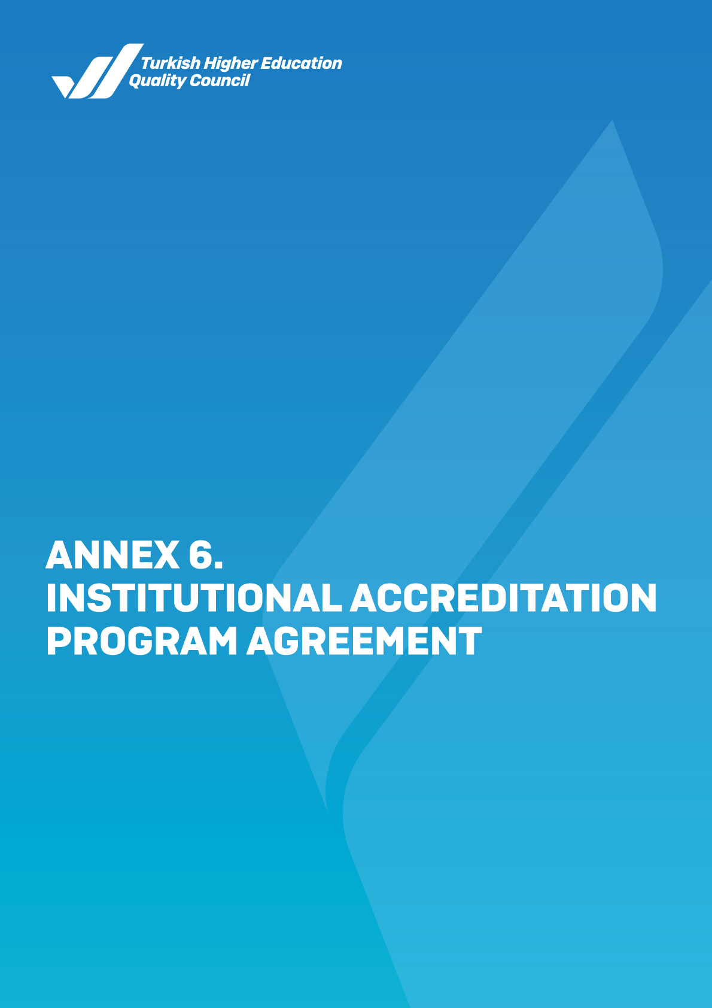

 |  | Logo of the Turkish Higher Education Quality Council

INSTITUTIONAL ACCREDITATION PROGRAM AGREEMENT
- Applicable Legislation, Standards, and Documents

  - Law No. 2547 on Higher Education
  - Regulation on Higher Education Quality Assurance and the Turkish Higher Education Quality Council
  - Institutional External Evaluation Directive
  - THEQC Evaluation Criteria Version…..
  - THEQC Evaluation Programs Guide Version .…
  - Other Documents

- Parties to the Agreement and Notification

  - Parties to this Agreement are:
  - Turkish Higher Education Quality Council’s:
Address: Üniversiteler Mh., 1600. Cad. No: 10, 06800 Çankaya / ANKARA
Tel.: 0312 298 78 83 e-mail: yokak@yokak.gov.tr
Fax: 0312 298 78 82 KEP address: yuksekogretimkalitekurulu@hs01.kep.tr

  - The higher education institution's (HEI):

Address: Fax:
Tel.: E-mail:

  - Issues Regarding Notification

    - The addresses mentioned above of the parties are the basis for notification. Address changes are to be notified to the other party immediately. If the party that changes its address fails to report its new address, the provisions of the Notification Law are applied.
    - In order to ensure efficient collaboration; the parties may notify each other through fax or e-mail, provided that the original copies of the official letters and documents are sent subsequently.

- Scope of the Agreement
This agreement covers the administrative and financial rights and obligations of parties regarding the evaluation of the quality levels of the leadership, governance and quality, learning and teaching, research and development, service to society activities of a given higher education institution, as well as making an accreditation decision, suspending or withdrawing the accreditation decision, fees, and confidentiality and security rules within the scope of the Institutional Accreditation Program (IAP) to be carried out by THEQC.

- Rights and Obligations
  - Rights and Obligations of the HEI

    - The HEI submits this agreement, which bears the wet signature of the rector/director, to THEQC.
    - The HEI agrees to allow the examination of all its documents related to the evaluation processes within the scope of the IAP by THEQC and the evaluation team and share these documents. If requested, the institution shall deliver the relevant information and documents to the evaluation team as soon as possible.
    - The HEI shall inform THEQC whether it has any conflict or coincidence of interest with the evaluation team formed by THEQC.
    - The HEI shall take the necessary measures for the evaluation team to carry out an efficient and effective evaluation process.
    - The higher education institution mutually determines the site visit dates with the evaluation team.
    - The HEI shall agree that the meetings to be held online within the scope of the site visit are recorded by THEQC.
    - The HEI shall undertake to use the institutional accreditation label and certificate within its scope after the relevant accreditation decision is taken.
    - The HEI shall not use the institutional accreditation label for program accreditation.
    - The HEI shall have the right to publish the accreditation decision and use the decision in its general correspondence.
    - The HEI shall have the right to appeal the accreditation decision within sixty (60) days from the notification of the decision.

  - Rights and Obligations of THEQC

    - THEQC evaluates the quality levels of the leadership, governance and quality, learning and teaching, research and development, and service to society activities of the higher education institution in accordance with the applicable versions of the documents, considering the evaluation year and term as well as the documents in use for that time, included in Part 1 of this agreement with the evaluation team to be formed, and decides on accreditation.
    - Within the scope of the IAP, THEQC staff and evaluators act in accordance with The Turkish Higher Education Quality Council's Code of Ethics, and the assigned evaluators are obliged to sign the Statement of Confidentiality and Code of Ethics.
    - THEQC publishes its accreditation decision and the Institutional Accreditation Report on its official website.
    - THEQC is obliged to preserve all kinds of information and documents obtained from the higher education institution under the IAP in accordance with the rules of confidentiality and security.
    - Records of online meetings held in the IAP are kept by THEQC and are not shared with third parties.
    - THEQC shall finalise the appeals and complaints filed by an HEI.


    - If THEQC determines that an HEI does not hold the accreditation qualifications, it shall have the right to revoke its accreditation decision.

- Confidentiality

    - During the IAP work defined in the agreement, all of the following items disclosed to THEQC and the Evaluation Team by the higher education institution are considered confidential: the processes, ideas related to business development, projects, inventions, works, methods, progress, and patents, copyright, trademarks, trade secrets or any other innovations subject to legal protection or not, any commercial, financial, technical information and conversational information in written or verbal form.
    - Any evidence, information, documents, institution name, title, and other information and documents related to the IAP mentioned in this agreement are confidential, and therefore they will be disclosed only to the authorized Evaluation Team and THEQC staff on a need-to-know basis, and this information and documents will not be disclosed to any real and/or legal third persons and organizations other than those who are entitled .
    - No comments and records made by the evaluation team and THEQC shall be used, published or shared with third parties for purposes other than the evaluation program.
    - Nothing shall be shared on the written, visual, or electronic media and social media channels regarding the content of the evaluation process and the result until the evaluation process is completed.
    - THEQC accepts and undertakes that its staff or those doing business on their behalf are jointly or severally liable for acts contrary to the confidentiality stipulated in this agreement and that its staff or those doing business on their behalf will comply with the confidentiality principles. The HEI shall be primarily responsible to THEQC for the attitudes and behaviours against the confidentiality of those who represent it.

- Validity of the Agreement
This agreement comes into effect after being signed by both parties and is valid in all accreditation processes.

- Authorized Court and Enforcement Office in Case of Dispute
This agreement consists of 7 (seven) articles and is issued in duplicate. In case of disputes related to this agreement and any additional protocols within this agreement, the laws of the Republic of Türkiye shall apply, and Ankara Courts are authorized to settle the dispute(s).

On behalf of THEQC: On behalf of the Higher Education Institution:
THEQC President's Name-Surname and Signature Rector/Director's Name-Surname and Signature

Date: Date:



